Research Daily Journal – Anuar Santoyo

2023.02.15

I read the Master Thesis “Mechanical Design and Aerodynamic Evaluation of a Bio-inspired Morphing Wing” from Luca to get an idea of what a good thesis looks like and started reading DR Sudeep Dissertation “Kinematic Analysis of a Bat Flight Based on Membrane Wing Motion Reconstruction”. I also started researching on papers regarding training robots with reinforcement learning.

Todos:
- Read Dr. Sudeep Dissertation

2023.02.16

Kept reading Dr. Sudeeps dissertation, and added some questions. Proposed paper idea (AAAAa le mamó!!) started working on sketches ideas.

Todos:
-Read Dr Sudeeps dis and make questions quote – “the more the better”

2023.02.17-2023.02.19

Finished reading Dr. Sudeeps dissertation and wrote down questions. Had meeting with Dr. Sudeep, questions were answered. Thought of way of achieving dynamic hovering testbench.

2023.02.20

Prepared Presentation of thesis proposal idea with static and dynamic tests. Found papers on reinforcement learning in flying machines.

TODO:
- Learn more about controlling
- Focus on application of ML on controlling optimization

2023.02.21

Watched several videos regarding control theory, as well as a series from mathlab to control drones. Read papers that use genetic algorithms to optimize PID controllers. Watched a bunch of videos of flapping robots

TODO:
- Improve presentation

2023.02.22

Gave presentation, had good feedback. Conclusion was to focus on developing the static test first and whilst doing so keep an eye open for useful things for the dynamic test. My actual plan is to read as many papers regarding controlling, genetic algortihm and flapping robots to migrate from a naive idea to a mature one. Hopefully I will soon have the chance to interact more with the robot to gain more insight in its dynamics. I opened many papers that might be interesting.

TODO:
- organize computer and papers

2023.02.24

PID seem to be widely used in drones. RL might be out of scope as it need many repetitions usually achieved with a simulation environment. We try to prove that GA tackles this issue directly in the real world.

Some summaries of interesting papers (note, the names of the data had been changed to fit in the thesis proposal on 23.05.08 uuuuu I come from the future):

data_driven_insects.pdf:
references CMA. also uses 2 steps GA, uses real ant data as part of the score in GA, one layered NN optimized with GA. THEY ALSO USE CMA!!! and explain it. They use simulations :/ (Simulation framework: Bullet). Question, can it be applied in real world? They used a lot of parameters (Stage I 198, Stage II 608), we might need far less. Conclusion: Exiting to see they use same basic ideas(2 Stages and CMA), unfortunately they apply in simulation, but on the other hand they optimize in very high dimensions and we don’t. Might be useful for initial hyper-parameters, and as inspiration to use real bat data.

dc_motor_pid_ga.pdf
Explains traditional method of tuning PID and compares it with better performing GA optimization. Clear description of GA hyper-parameters.

pid_ga.pdf
most populat controles pid, clear advantages of GA are described.

bird_control_ml.pdf
Talks about the difficulty of simulating airflow in mid Reynolds numbers and the computation expenses of it. ML and data driven might be better to finding approximate models compared to only physics.

flapping_bird_controll.pdf
Advantages of flapping robots is described. Mass and inertia of wings cannot be neglected (advantage for us as the mass of wings is very low). 500Hz control frequenc using FreeRTOS. They analyze force and moment produced by wings and tail separately. For control combination of fuzzy and pdi. They use averages for a whole flap cycle (divided in upstroke and downstroke). Use interesting fixed to a moving mechanism for test (good for our dynamical test). Extensibly explains hardware used, including sensors. Baromeneter MS5611 used with 10cm precision.

flapping_model.pdf
Mostly deep aerodynamics explanations and analysis. Mentions that elastic wing flapping is largely unexplored. Intereseting figure showing hovering aerodynamic from a hummingbird. Too aerodynamical. Use similar structure as the one planned for the static test. Ussing only one Ft Nano-25 force sensor.

hovering_flapping_controll.pdf
Hovering strategy by changing wing flap velocity.

model_flapping_robot.pdf
Reference papers that achived hovering for flapping wings. Mentions that most flapping control is based on wing frequency and mean angle of attack (interesting, the fact that they use mean angle of attack can be useful). Used simulations

mechanism_flapping_vehicle.pdf
Very straight forward explanation of design of flapping bird.

summary_robot_rl.pdf
DRL often needs tens of millions of data samples to learn meaningful locomotion gaits. Robot safety is a bottleneck. In Summary, we can forget about RL (question arises, even for such a small dimension as ours)

Links
Control Theory tutorials
https://engineeringmedia.com/videos
Best controlers
https://robocraze.com/blogs/post/best-flight-controller-for-drone
RaspPi Controller
https://www.unmannedsystemstechnology.com/2022/06/raspberry-pi-based-flight-controller-os-for-rovs-and-robotics/
ESP8266 drone tutorial
https://www.instructables.com/Build-Drone-With-ESP8266/

All to the day pending papers were read and summarized. Started hardware selection investigation.

Created Hardware Selection file. Until now, NodeMCU with arduino and pyhton communication look promising. Need to check if NodeMCU is powerful enough for flight control.

TODO:
-find more applications of CMA
- Ask Dr. Sudeep for BCS data
- check nodemcu

2023.02.25

Quickly checked accuracy of barometers (around 15cm, good enough). Decided to use ESP8266 and python and saw couple of tutorial regarding connection. Actual main idea, use NodeMCU with accelerometer/gyro module and barometer as sensors. Apparently Dr. Li is working on static bench design (from the mechanical part) so I will focus on the software part.

TODO:
-Buy:
-NodeMCU 2021
-MPU-6050 IMU (accelerometer/gyro)
-Grove - High Precision Barometric Pressure Sensor (DPS310) Acc 2cm

2023.02.27

Ordered ESP8266, arrives in 2 days. Meanwhile preparing computer using https://www.instructables.com/ESP8266-and-Python-Communication-ForNoobs/.
Started to look for options to connect pressure sensors from Dr. Lis test idea. RaspberryPI has no analog input, arduino does.

https://realpython.com/arduino-python/ used to connect sensors to python using an arduino uno

Update: using tutorial from https://www.learnrobotics.org/blog/arduino-data-logger-csv/ to connect sensor_arduino with python we better read the data from within arduino printed in the serial monitor and from there obtain the data for python. The last idea was to use a loop from python to call the data from the arduino using framatta. Bad idea as python takes a little delay with each reading and they accumulate throught time.

2023.02.28

Using https://www.learnrobotics.org/blog/arduino-data-logger-csv/ idea I created a first working prototype of communications between pyhton and arduino. Can be seen in sensor_arduino.ino and ardunio_serial_sensor.ipynb. Started the first draft of the whole framework and included place holding functions.

2023.03.01

Managed to successfully read data from the GY-85 9DOF IMU Sensor Module using IMUGY85.h module. Able to send data collection command from python to sensor and retrieve data in pyhton and plot. Program is ready to be tested. Python commands measurements and they are gotten from the ugy 85, constructed first test bench for prove of concept.

Prove of concept consists in a servo connected to an accelerometer. As the servo moves, the sensor measures the changing strength of gravity with respect to one axis. The servo is commanded to move in a sinoidal way, the parameters of the trayectory are the amplitude and frequncy of the sine. The idea is to use the constructed framework to see through iterations the servo can find the correct amplitude and frequency to imitate an arbitrarily given sine function.

Spend a lot of time trying to make rest of microcontrollers work.

TODO:
- See if you can make servo run on any microcontroller (until now only one works and they have to be different as sensor and motor must work in parallel)
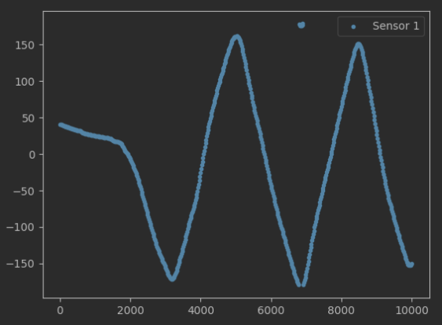

2023.03.02

Today was a good day, finally made ends meet. The ESP8266 arrived and I was able to connect it and control it using https://randomnerdtutorials.com/esp8266-web-server/ and passing instructions as a html request. Started testing the simultaneous command and sensor and it works, unfortunately the sensor is not working as expected, giving funny signals even when static. That is why the next steps are to fix or find a better sensor reading. Second issue is that the way I am currently controlling the servo creates a zig zag more than a sin function, I believe a sin function is better for presentation purposes. Prof. Zhao asked me to make a presentation next Thursday showing my advances and with a more detailed planning on the experiment set up.

TODOS:
- Correct sensor readings
- Correct servos sine function
- Apply on main CMA algorithm and optimize
- Make presentation for it.

2023.03.03

Built prove of concept prototype using a potentiometer. Achieved much more reliable measurements. Worked on the post processing of the raw measurements and on the calculation of the fitness model, also used experimental data to arbitrarily choose a goal sine function that will be used in the tests (amplitude 30, frequency 2). Corrected the servo code and sines are now created instead of zig zags, never the less there appears to be some kind of issue with the connections as the servo sometimes goes unreactive or crazy. Must give another look to obtain constant repeatable tests. Also started working on the visualization of the algorithm for the presentation.

TODOS:
- Repair servo
- Test limit values in frequency to achive larger amount of test domain.
- Create simulation of CMA using sine to choose better hyper parameters to find quicker solution when doing the real test.
- TEST CMA BABY!!!!(:

2023.03.04

Repaired servo problem, when servo starts it requires a lot of energy, when it demands more than what the arduino can provide arduino resets ( or something like that). The solution was to connect the MEGA to the powersocket and feed the the servo power (which is controlled by the ESP) from the MEGA. Also, using direct command to return to base position was demanding. So I implemented a small P control to return to base position.

Extreme values were analyzed. The decision was made to use amplitudes between 0-90 and frequencies between 0-5.

2023.03.05

Successfully created CMA simulation to analyze best hyper parameters. I will be using n_pop of 5, sigma and sigma of 1. Started testing whole framework on prototype. Minor bugs were fixed.

2023.03.06

First successful test using whole system!!! (awebo) It optimized beautifully, I worked on better visualizations and plots to understand the process of optimization (took much longer than thought of, specially the pinche ellipse. The ellipse to so long because the optimization domain is between (0,1) and it is then scaled for the commands, to draw the ellipse in the transformed domain took way to long, I read for hours stuff from cov matrix to linear transformation…. At the en decided to do the whole the visualization in the optimization domain and only scaled the labels of the axis (cheating? Yes, but non relevant for a simple presentation :D ) Started preparing presentation for tomorrow.

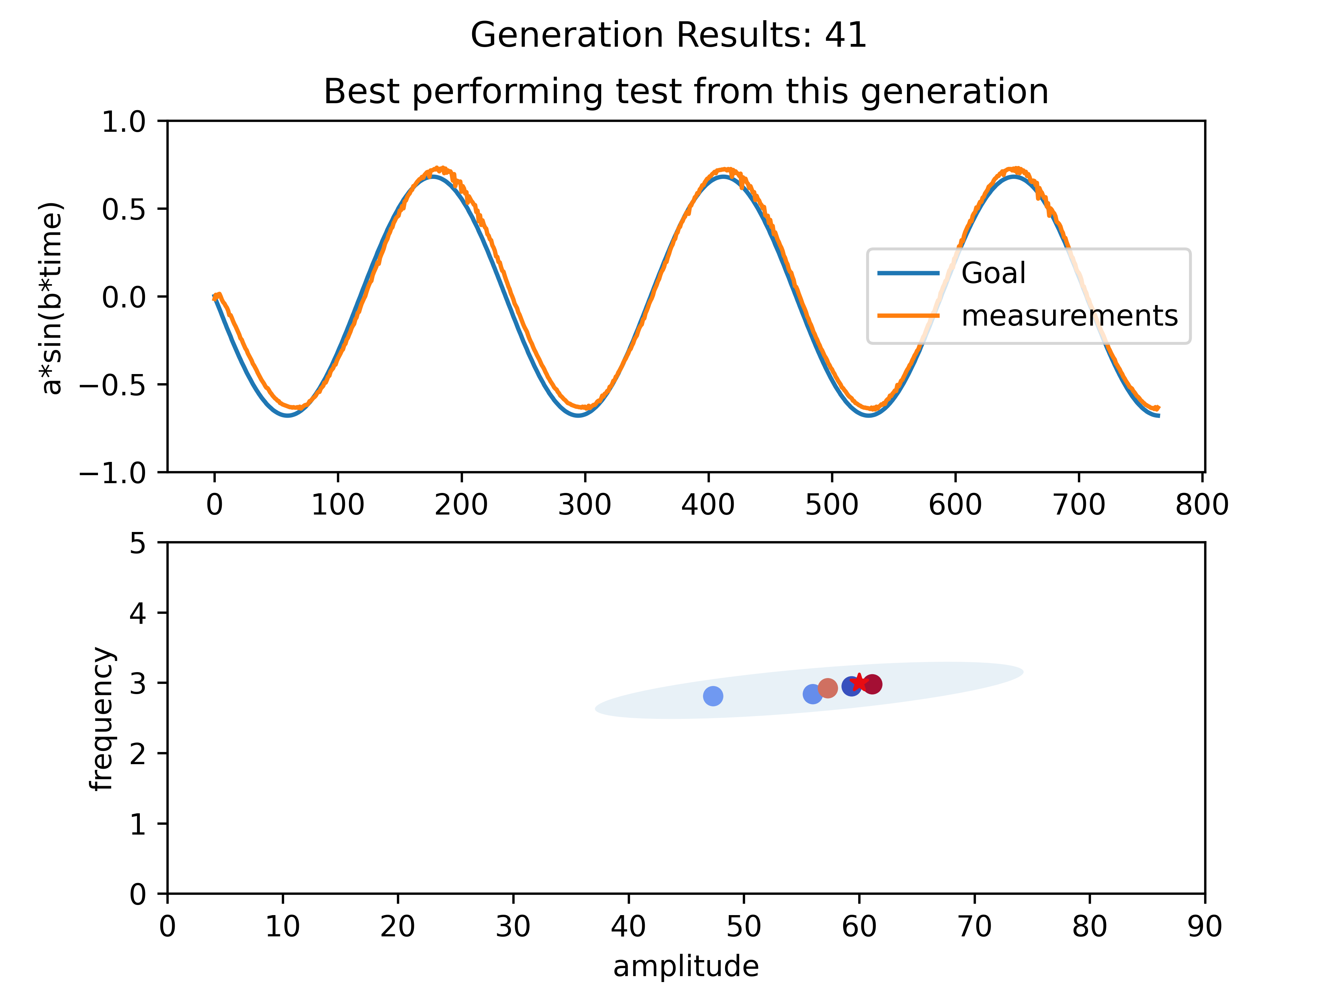

2023.03.07
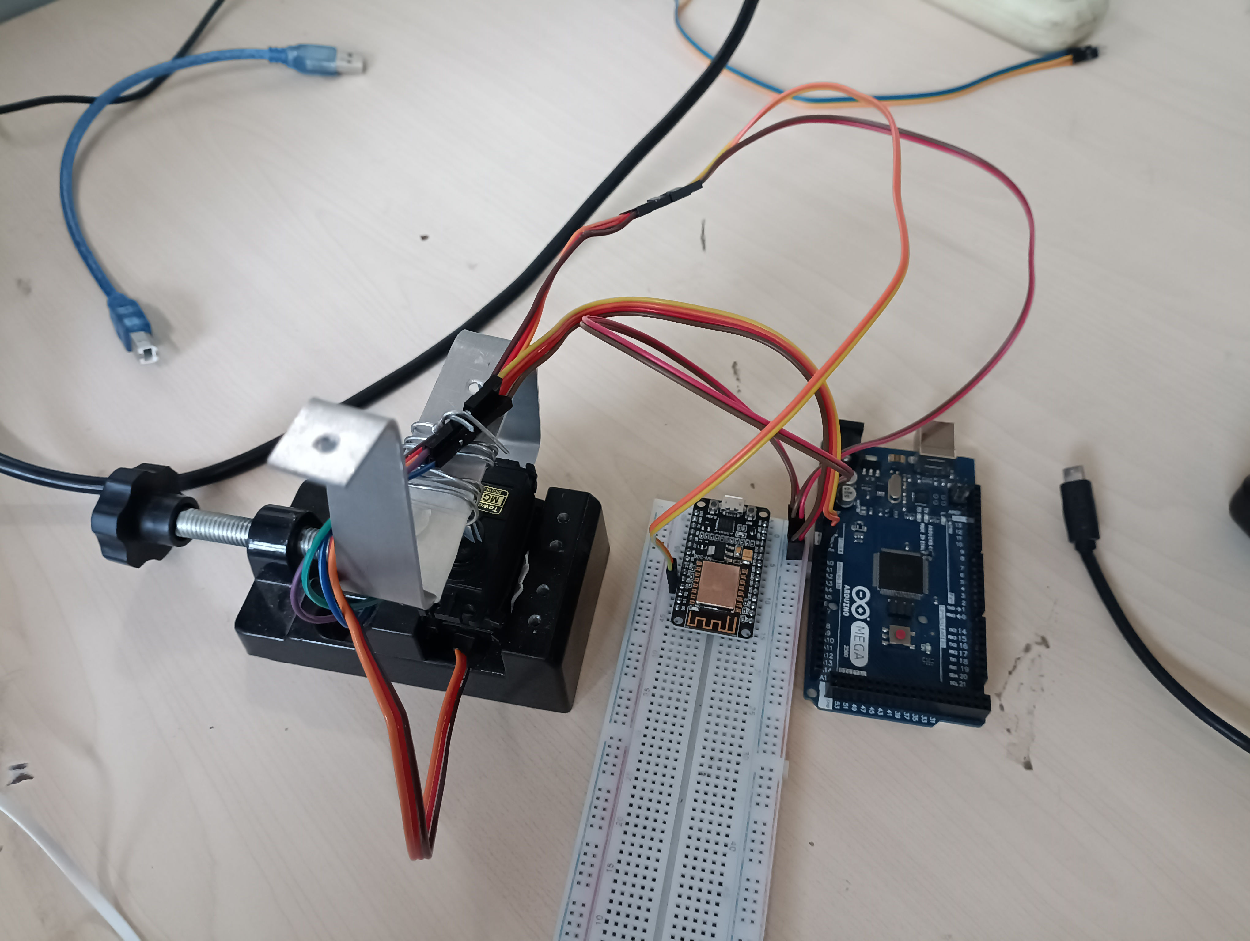

Finished final touches of presentation, created gifs of optimization and improved minor detail. Presented, it was a good presentation. Had very good feedback, to have a running prototype in 2 weeks was found to be “impresive”. Prof. Zhao commented that if whole control loop happens in less that 30 milisecond, that we will have better chances on controlling the batbot. Dr. Li asked question regarding the relationship between amplitude and frequency on my prototype, was not able to explain in detail (not sure if I understood the question completely). Either way, this shows the urgency on understanding the control on the real Batbot (btw.. the name Batbot was also very celebrated and now everybody uses it). 2 important questions rouse from the presentation:

1st : Is the esp8266 powerfull enough? How are microprocessor measured, what is relevant? How does the esp8266 compare to the microprocessor being used at the moment?

2nd : How to control robot? Are we sending sin waves and changing parameters or juat?!?

2023.03.08

Dr. Li gave me the code in C of the robot and explained me that the actual issue is that the servo cannot flap at the same frequency as the wings (5-8Hz). The present goal is to achieve a sinusoidal wave movement of 5hz with an amplitude of 38°. Dr. Li says that when the frequency increases the amplitude changes. I created a simple arduino program to run the test. It looked like it worked but when I showed it to Dr. Li he said that we need to measure the amplitude to see if it actually makes the desired trajectory. He gave me a hall sensor for roation measurements. I spent time trying to find documentation about it.. unsuccessful. So I decided to test it.

2023.03.09
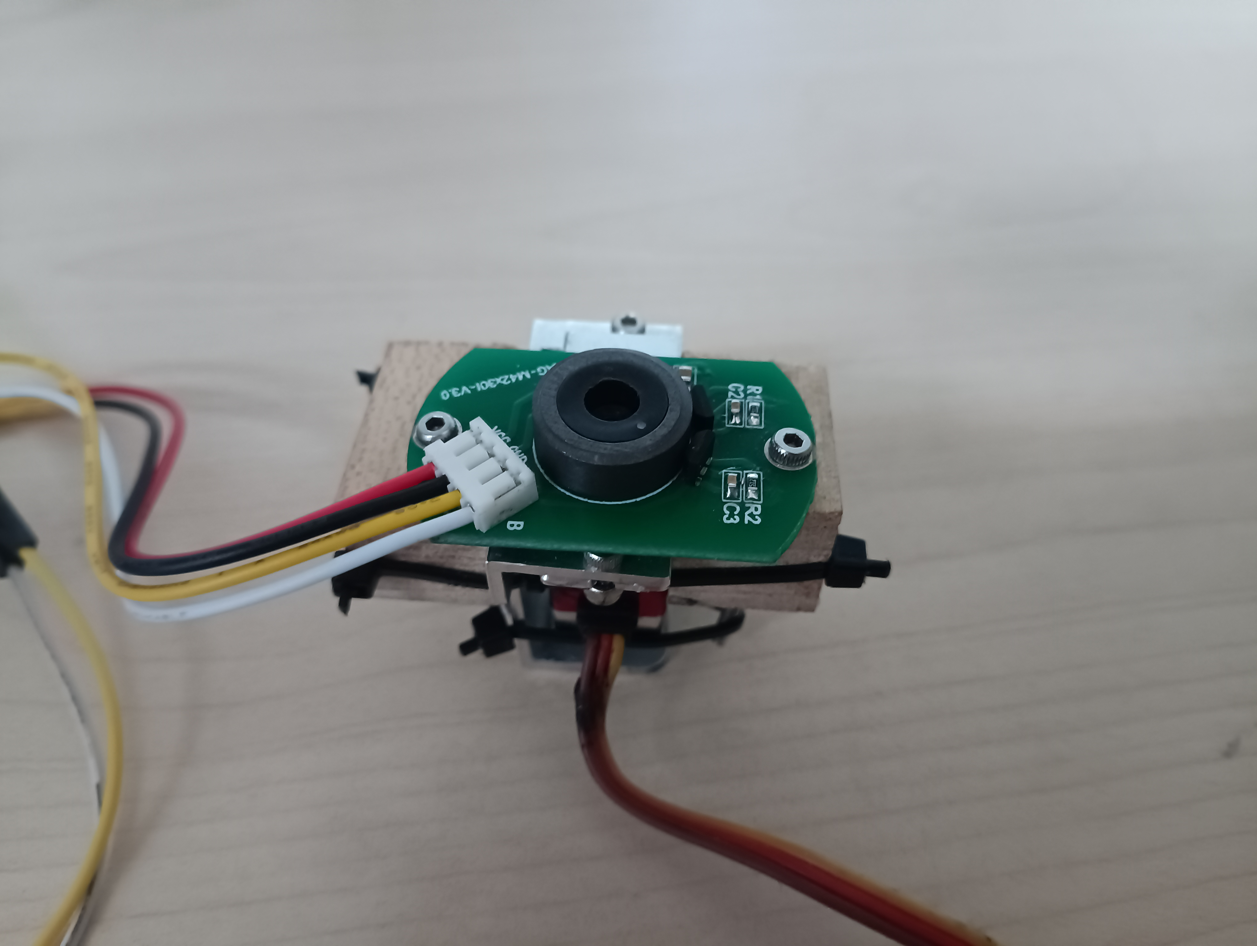

Built with wood and stuff I found in the lab a little test bench for the servo amplitude/measurement (took a while)

Read raw data in Analog and tried to find out how to obtain angle measurement from it. While experimenting… I broke it. Had to wait until Sunday to continue with experiments. :D

2023.03.13

Sensors arrived!! Installed new one. Organized files and created Github Repo. Created framework for testing frequency. 5Hz with 40° amplitude were achieved, we will do tests tomorrow on the real robot to count the friction factor aswell in. IDEA: use second NodeMCU for measurements to send data wirelesly.

2023.03.14

Dr. gave me a DC motor to try to control using the arduino, was straight forwardly achieved. Afterwards Dr. Li gave me a Pixhawk Lite to try to learn how it works. It seams that he prefers to use the Pixhawk over the arduino. I started learning how it works to see of its advantages, it might be useful to understand its workings in case the NodeMCU proves to be not powerful enough. I still miss to see completely the reason of using the Pixhawk when I have already built the whole infrastructure with the arduino and NodeMCU. Never the less I will give an initial research to better understand its workings and make better recommendation.

Pixhawk Lite research:
- Programming from scratch seems difficult, never the less there are some tutorial that show how to connect an raspberry pi with the Pixhawk. If this can be achieved, then we have the best of the two worlds. The Pixhawk speciallity on flying controls and the communication framework using raspberry pi.

To learn:
- MAVLink
- SSH
- putty

Raspberry + Pixhawk:
-https://www.youtube.com/watch?v=kB9YyG2V-nA
-https://www.youtube.com/watch?v=BSDST7ePOtM
-https://www.youtube.com/watch?v=cZVNndOaYCE
-file:///home/anuarsantoyo/Downloads/CommunicatingwithRaspberryPiviaMAVLink.pdf

Arduino + Pixhawk:
-https://www.youtube.com/watch?v=NlPEn-53Ze8

Mavlink:
-https://www.youtube.com/watch?v=bBlve-x9nxE
-https://www.youtube.com/watch?v=iZ-usX1VXRI
-https://www.youtube.com/watch?v=qLfxzeKu2Hg&list=PLSzYQGCXRW1Gk3C7fh7tVE92UKOn-chtg
-https://www.youtube.com/watch?v=kecnaxlUiTY

2023.03.15

I talked with Dr. Li and we concluded that using Pixhawk is not the best idea as it is difficult to program and support mostly fixed winged drones or copters (not flapping robots). He explained how he controls the robot and the actual limitations. He recommended me to learn to use the micro-controller he uses STM32, I was not so convinced at the beginning as I had everything already done in Arduino but after initial research it seem STM32 is much more professional and is used in real product development. Also Arduino and STM32 are not so different, and as Dr. Li mentioned it will be much more efficient if we both use the same micro-controller. So I spent the day watching STM32 tutorials and installed the necessary software.

STM32 tutorials:
- https://www.youtube.com/results?search_query=stm32cube+tutorial
- https://www.youtube.com/watch?v=gL8OoS9E1rw&list=PLnMKNibPkDnFCosVVv98U5dCulE6T3Iy8

- https://www.youtube.com/watch?v=sQCqVBuq-gA&list=PLnMKNibPkDnGtuIl5v0CvC81Am7SKpj02

- https://www.youtube.com/watch?v=sQCqVBuq-gA&list=PLnMKNibPkDnGtuIl5v0CvC81Am7SKpj02

- https://www.youtube.com/watch?v=eumKLXNlM0U (very good)

2023.03.16

Installed and configured STM32CubeIDE in computer. Watched a couple of tutorials and spent most of the day trying to make a pinche LED turn on. Had several issues, tried different chips different tutorials, different configuration. Most of the time was spent on trying to solve the error “initializing ST-LINK device. Reason: (4) No device found on target”. I tried changing certain lines of the stm32f1x.cfg file but it didn’t work.

Tutorials:

https://www.youtube.com/watch?v=Hffw-m9fuxc

https://blog.csdn.net/u014296565/article/details/110498140

https://www.youtube.com/watch?v=eumKLXNlM0U

2023.03.17

It finally worked. I tried with a chip I hadn’t used, namely the one in the board STM32FxCxT6 and it worked immediately without an issue. I had no LED to test it but I gave mini electroshock to my tongue and the pins that I declared in the program turned on and off as expected.

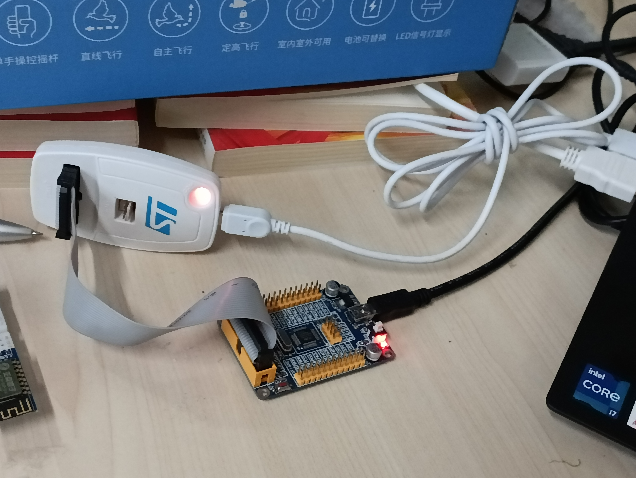

STM32F103C8T6
Started experiments with servo https://www.youtube.com/watch?v=AjN58ceQaF4, it worked using https://www.youtube.com/watch?v=TAAaE7cHdMQ.

Started research on wireless communication. Bluetooth can be an option https://www.youtube.com/watch?v=RPU2wzfewY8 as well as ESP8266. I did some unsuccsesfull tests with a ESP8266 that I found in the lab. Gathered a good sample of tutorials for ESP8266 to try .
Videos:
https://www.youtube.com/watch?v=hdkGWKNdzSs
https://www.youtube.com/watch?v=W22WsNbMNOM
https://www.youtube.com/watch?v=bPDCmvywusM
https://www.youtube.com/watch?v=FRAlFSaYb8c
https://www.youtube.com/watch?v=MG-5Ct_rCZQ
https://www.youtube.com/watch?v=LS7owD8C_tI

Tutorials
https://circuitdigest.com/microcontroller-projects/interfacing-esp8266-with-stm32f103c8-stm32-to-create-a-webserver
https://lupyuen.github.io/articles/connect-stm32-blue-pill-to-esp8266-with-apache-mynewt
https://github.com/smart-storm/storm-iot-node
https://circuitdigest.com/microcontroller-projects/interfacing-esp8266-with-stm32f103c8-stm32-to-create-a-webserver
https://controllerstech.com/esp8266-webserver-using-stm32-hal/

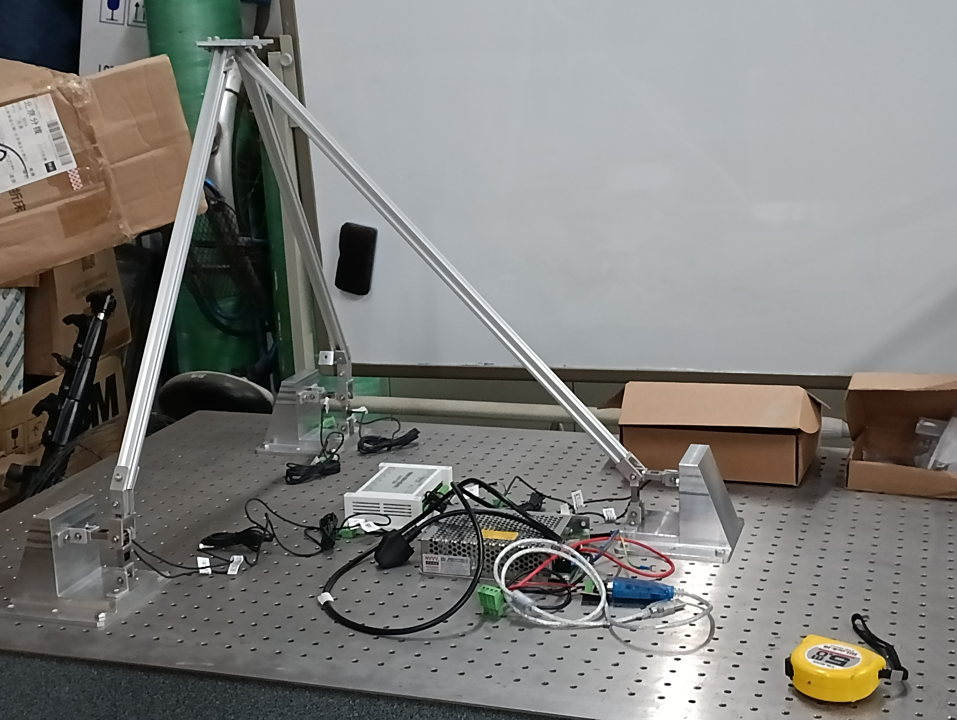
Note: I am now convinced that using STM32 is the best idea, it is much more powerful and professional. It is also what Dr. Li uses, so it is a good idea to use the same software, also the measurements from the test will be achieved by a hardware (which was installed yesterday by Dr. Li) so the main tasks right now are how to command the stm32 wirelessly and how to obtain the data from Dr Lis data logger in an automatic way to python so that the GA can work without the need of constant intervention. Everything is starting to look much more “scientific” using the hardware provided by Dr. Lin, compared to my naive initial idea of using Arduino…

And….. Baaam! Surprise task. Dr. Li asked me if I can help him put the membrane on the Batbot, as Prof. Zhao said that he wanted to present my idea in his international conference in Hong Kong ( !!!!) . So goodbye salsa and KTV hello preparing presentation until 2am(:. Interestingly, I enjoyed it. It is nice to see an idea starting to get in form, and if Prof. Zhao thought it was good enough to present it, then I will try to do it as best and quick as possible.

https://www.youtube.com/watch?v=lP0ehhbb1eQ

2023.03.26

Last week I was sick, it started on the evening of Sunday and I spent in bed until wednesday, from there I had two homeworks with approaching deathlines so I had to spend my time doing that.
The advancements made on the project this week could be summarized in a better and deeper understanding of the esp8226 module, I can now program it using AT commands from the arduino serial monitor. I spent a lot of time trying to connect the esp8226 to the STM32 unsuccesfully, on the coming days I plan to follow a detailed tutorial that aims to solve this, if that is not succesfull I plan to configure the ESP8266 independently to send strings of data when a get request arrives and learn how to process the string in STM32 using serial communication.
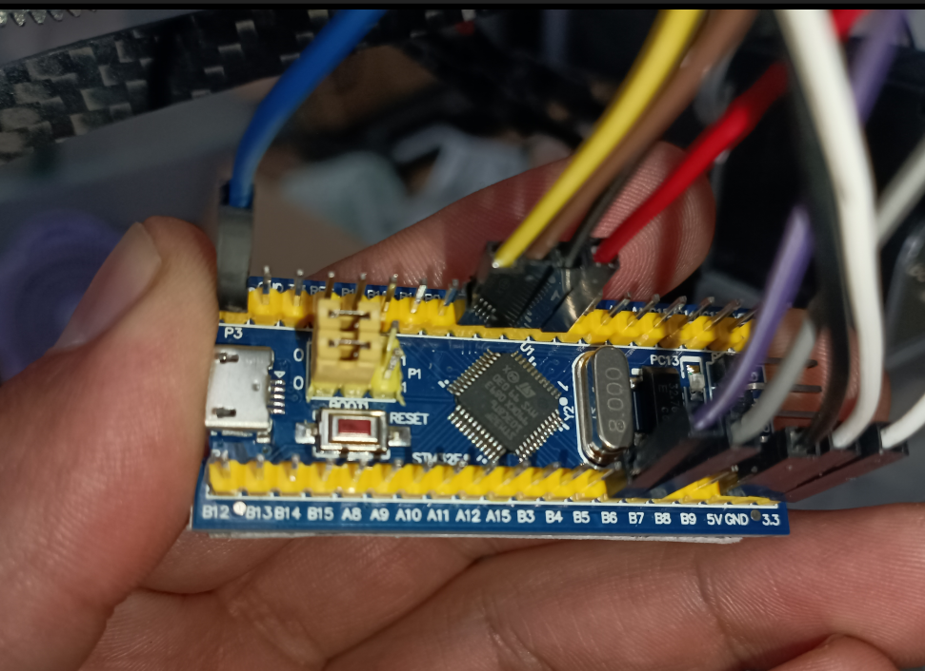
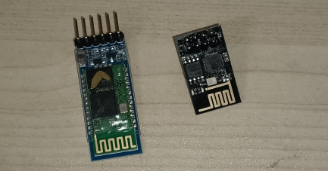
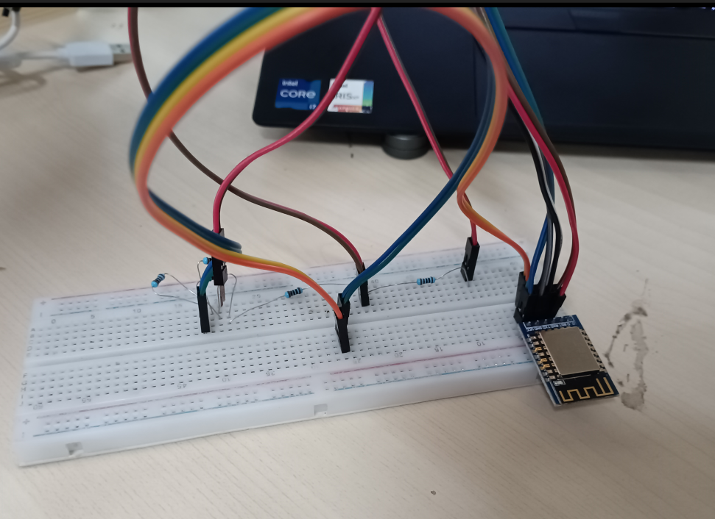

Today I prepared a presentations of advancements and future steps for tomorrow.

2023.03.27

Connecting the ESP8266 is proving to be more challenging than expected, I think I first need to better understand how does the serial communication of the STM32 works, as without it I am not able to know if the EsP8266 is actually working, so my next steps are based on understanding and testing serial communication between STM32 and the computer. UPDATE: I ended up burning something and now I ordered a new arduino. I have to be more careful this components are not idiot proof, I fear I might have burned some from the beginning and spent hours trying to make a burned component work.

2023.03.28

I used the NODEMCU to directly command the ESP8266 in AT mode. This tutorial is the one that should be followed to make AT commands work.
https://electronza.com/esp8266-at-mode-webserver-tutorial/

The pinout it quite simple (keep in mind that NodeMCU uses 3.3V) if you use arduino you might need to do some electro magic to reduce input voltage. (https://learn.circuit.rocks/using-at-commands-on-the-esp8266) ← pinout!! I am sure I burned some of my first ESP8266, lesson learned.

ESP8266-NodeMCU
gnd-gnd
tx-tx
rx-rx
3,3-3.3
ch_pd/en-3.3

Baud rate:115200

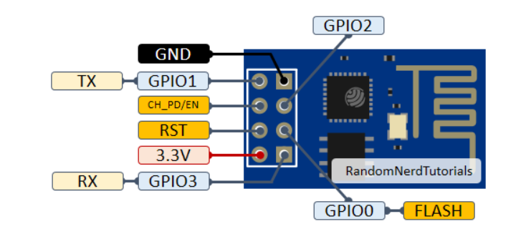

HTTP/1.1 200 OK
Content-Type: text/html
Connection: close
(here we might add additional info in the future to send back after request, but not a priority now)
Summary ESP8266 for future reference:
Every time you start ESP8266 we need to initialize it as follows:

AT+RST
AT+CWMODE=1
AT+CWJAP="batbot","12345679"
AT+CIFSR
AT+CIPMUX=1
AT+CIPSERVER=1,80

then we can send Get commands with python, that need to be responded from the esp8266 with:
AT+CIPSEND=0,55

HTTP/1.1 200 OK
Content-Type: text/html
Connection: close
AT+CIPCLOSE=0

Today I gained a much better understanding of the ESP8266, which was explained in the last part. I saw a series of tutorial for STM32 (https://www.youtube.com/watch?v=hYYRfhhvTYo&list=PLr0mEvO7yBe6Ga7wJpRTZpxAYSvgWY0A-&index=1) to obtain a even deeper understanding, as at the moment even though I can understand the ESP8266, it is not possible for me to create a connection with the STM32. I think that understanding UART and serial communication from scratch might be usefull. This video provided a good insight https://www.youtube.com/watch?v=JWOV4j5fCS4, can be a great starting point.

2023.03.29

Ok.. so after a couple slow paced days, I start to see advancement. I was finally able to proof that the stm32 is sending and receiving data. Doing the serial communication was to complicated and I still haven’t figured out how to connect it. All the tutorials that I have seen say that UART2 is by default connected to the usb exit of the board, never the less when I connect the USB to the computer it is not recognize, I guess it might have something to do with the fact that I am directly coding on the chip and that my STM32 project settings are done in the chip and not in the board. I solved this problem by connecting by enabling UART1 (RCC: Crystal, Usart in pic)

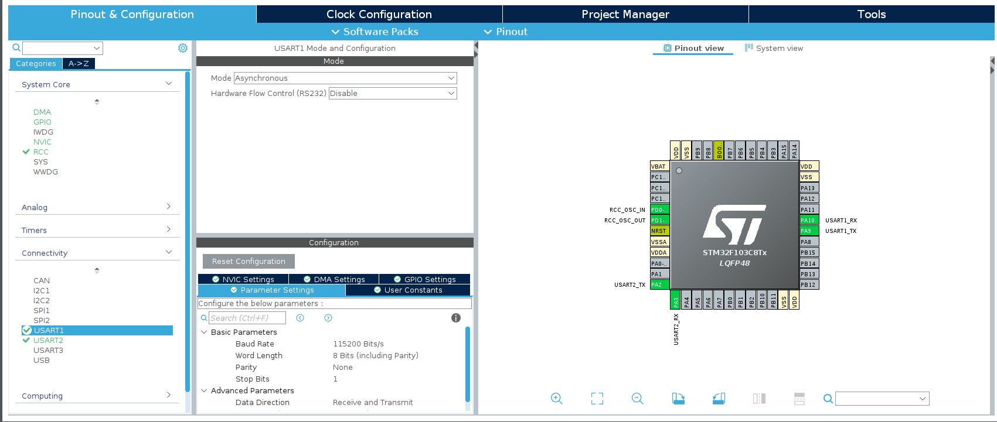
Then I connectedt the tx and rx to the tx and rx pin of the NodeMCU and used the serial monitor of the arduino to successfully send and receive data from the STM32, I sent a hello world message to the arduino and I could see the data sent from the serial monitor in the debuger mode of STM32. With this I can start with the real experiments, my following idea is to configure the ESP8266 using the arduino serial monitor (as I did yesterday) and then when it is configured just change the connection to send data to the STM32, from the debugger I will be able to see what is being received and start working to filter the relevant data from the get requests. The next step would be to slowly work my way to not depend on the arduino, but this will be accomplished step by step.

The problem arouse, that I was only able to send one byte of data to the stm32, after several tutorials this one (https://www.youtube.com/watch?v=Bo6MC5A8uTE&list=PLfIJKC1ud8gjhc4HiqVXUzcVq4iL5MqTz) was the only one that actually worked. With this, I receive all the string that I send from the arduino, instead of only the first char. The final test was to connect the ESP8266 to the arduino but connect the tx of the esp8266 to the rx of the stm32 and I was able to use ArduinosIDE to send At command and read the response from the ESP8266 debuger… alfin cgdm!!

2023.03.30

I achieved send AT commands form the arduino and the responses to be read from the stm32. The buffer was not being refreshed but only overwritten, leaving data in the buffer if the new data was shorter than the older, this was repaired. I was even able to obtain the GET commands from the ESP8266, there was some funny error when commanding AT+RST, somehow the uart_received gets a lot of data simultanously and then stops working. This was provisionally solved by not using the AT+RST command, the rest work fine. The next step before investing to much time is to use the current state with the HC05 (from which the new ones arrived today) If Hc05 is easy to programm this may eliminate the hurdle of needing to initialize th ESP826 with AT and also sending close commands to the get request. I believe with the HC05 I will be able to simply get raw data and work with that.

2023.03.31

I experimentes a for a while with the HC05. I proved to be also not as straight forward, I was able to send and receive data from the phone, but when connecting the tx and rx pins to the serial monitor I got large amount or rubbish data, I think that it could be solved, but I rather take advantage of the time invested learning ESP8266 and continue trying to use it, as now it looks more promising than ever.

I completed the whole cycle of stm32 Esp8266, I connected the STm32 to the esp using a voltage reductor for the rx pin of the esp8266 and wrote the code (huart_idleline) to initialize the esp8266 wifi config and also to close the connection when a GET request arrives. I also implemented a simple filter fucntion that extracts the values that are between $ and ! And saves them in an array called interesting. Once I know more about the exact working of the batbot I can adapt the array “interesting” to get relevant values for the experiments. The connections and commands were obtained from the tutorials mentioned on day 23.03.28. (after each AT command a \r\n is added in the stm32 code).
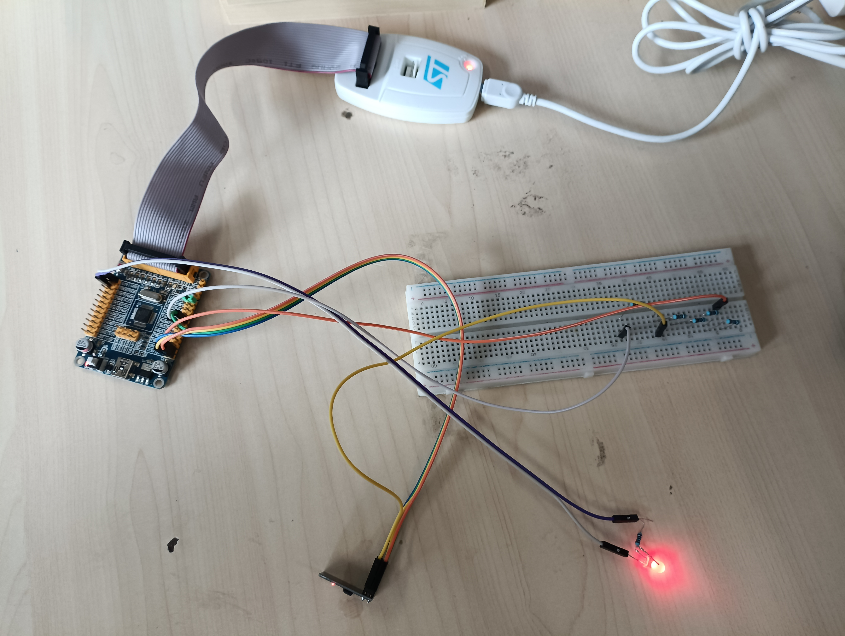
2023.04.01-02

Once the computer stm32 communication was achieved I decided that the most urgent next step is to obtain data from the sensors. Dr. Li has connected everything for the test bench and achieved connection with his computer. Unfortunately the software he uses is only for windows, I spent some time researching how to install windows on my computer but before doing that, I decided to try to make it work with Linux. For this I downloaded Labview instead, I saw a lot of tutorials were I also realized that using labview it would be very easy to get the data to python, the only problem that I face at the moment is that the data logger instrument is the BSQ-JNP8 (instead of the more known National Instrument). Therefore I have spent these days trying to connect the data logger with labview, for this apparently I need to install some drivers. I tried installing the driver NI-DAQ™mx
but was at first glance unsuccessful, never the less it was just a quick try and more has to be tried.

2023.04.03

I prepared the weekly presentation and presented it. Not so much attention was given and the feedback was just to continue with my plan, not sure if good or bad. Spent the rest of the day doing homework.

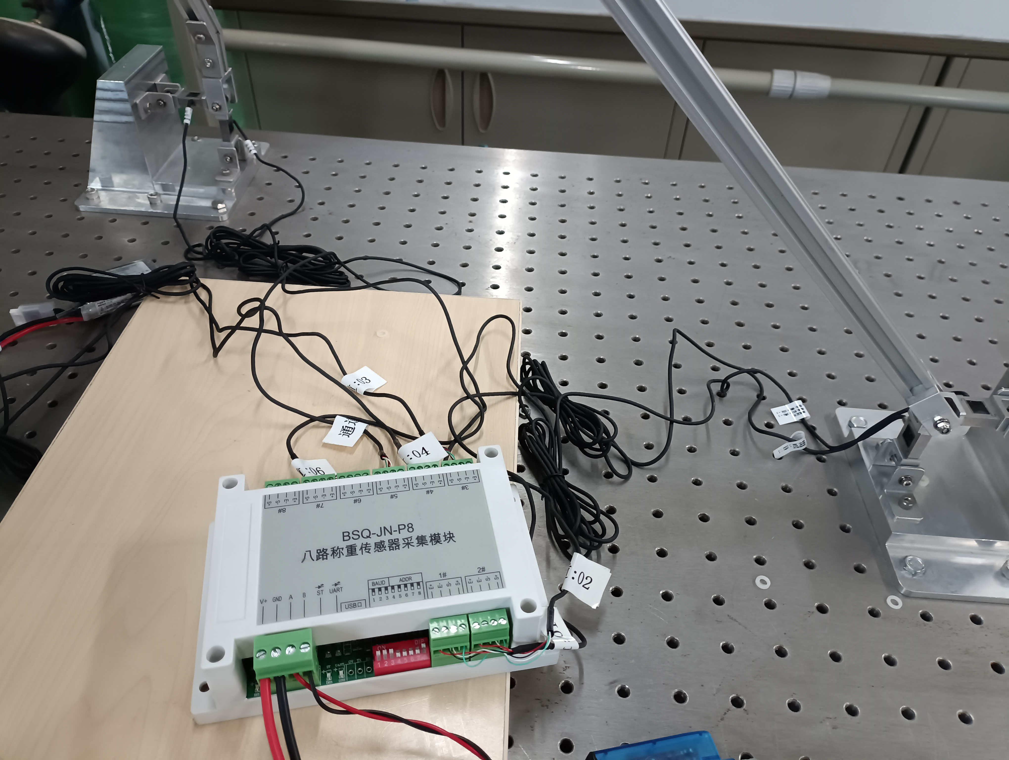

2023.04.04-07
Load Sensors

The Professor told me he is a research associate of a journal and we told me there was an interesting paper that he would like me to give a look at. Before I knew it I was register as a reviewer of his journal. The paper he gave me was about controlling a model of a hovercraft using a PD Fuzzy like controller, and using an algorithm to optimize the PD parameters of the fuzzy like controller. The optimization algorithm was the bacterial foraging optimization enhanced using the particle swam optimization in a specific step of the bacterial foraging algorithm.
I spent a day at first trying to understand the algorithm, I had to read some of their referenced papers to get familiar with the topic. I found the concept of biomimic algorithm very interesting and could consider it for a future possible path for me. I particularly learned about the particle swarm optimization, bacterial foraging strategy and pd like fuzzy controllers. Then I was able to understand the paper, then I made a first corrections and comments based on what I know (following the professors advice). Once I was finished I showed it to the professor and Dr. Li, the professor was very excited with my comments and gave me a very positive feed back. He then offered me to give a talk to his undergraduate student about paper reviewing and correct scientific writing (ja! La mamaaáh). Then I made a deeper research on correct scientific paper, corrected some parts of my review based on my newly gained knowledge and submitted my review to the journal.

2023.04.08-09

I got back to trying to connect my computer with the data acquisition instrument (DAQ). I am still in the first general research face of the problem solution. I am watching tutorials and seeing if it is possible to connect the DAQ with python directly.

2023.04.10

Tried for a while to correctly install Labview and the DAQmx drivers, I installed and reinstalled and uninstalled several times as it gave no results ( the DAQ assitant was not showing in Labview). Then I tried skipping Labview and trying directly with a program provided by the drivers (NI Hardware …) I then tried to directly connect to the module using python. This search oblige me to better understand the BSQ-JN-P8 and realize that it uses serial communication, for this I tried to connect it to python. I had just managed to make a connection, the next step will be how to retrive data (if possible). For now here is how I made connection:

- I first needed to find the path of the DAQ, this is achieved using the command:
sudo dmesg | grep FTDI in the terminal

- then I used the following code with the found port:

####################################
import time
import serial

ser = serial.Serial(
port='/dev/ttyUSB0',
baudrate=9600,
parity=serial.PARITY_ODD,
stopbits=serial.STOPBITS_TWO,
bytesize=serial.SEVENBITS
)

ser.isOpen()
#####################################

After experimenting with pyserial using arduinos, and also learning how to use the serial terminal from the computer I followed the question posted in: https://stackoverflow.com/questions/74935263/can-t-read-register-of-modbus-using-python-via-485?rq=4

and with the code:
import serial # import the module
ComPort = serial.Serial('/dev/ttyUSB0') # open COM4
ComPort.baudrate = 115200 # set Baud rate to 9600
ComPort.bytesize = 8 # Number of data bits = 8
ComPort.parity = 'N' # No parity
ComPort.stopbits = 1 # Number of Stop bits = 1
ComPort.write(b'\x01\x03\x00\x00\x00\x02\xC4\x0B')
ComPort.read()
print(ComPort.read(), 'a')
ComPort.close()
I had my first communication with the BSQ-JN-P8 (DAQ), so as I had supposed, the DAQ awaits for a specific command to return any information.

2023.04.11-12

I spent the last 2 days better understanding how the modbus protocol works. I saw several videos and tried learning how to use the python module pymodbus. Unfortunately, after I while trying I was not able to make the module work, I believe that with a better understanding, the module should be the easiest way to communicate with the DAQ. As I was already able to successfully communicate with the DAQ directly using serial, I decided to instead understand from scratch how does the communication with the DAQ work and create a python implementation of my own to get my data. For this the documentation of the DAQ (provided by Dr. Li) was incredibly useful. After a couple videos and many attempts I got a hold of how it worked and I the end I found myself manually converting bytes to floats (those informatics classes were not so useless after all). So at the end I was able to obtain the data from the sensors, convert it and save it in a data frame.

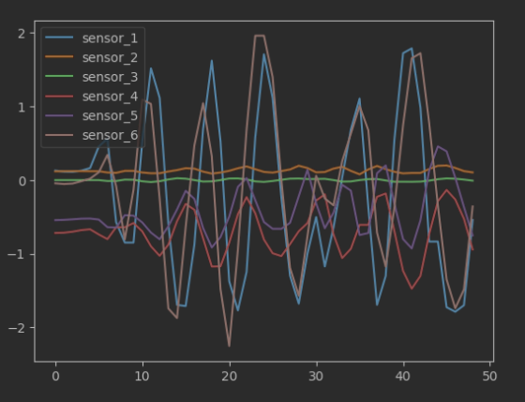

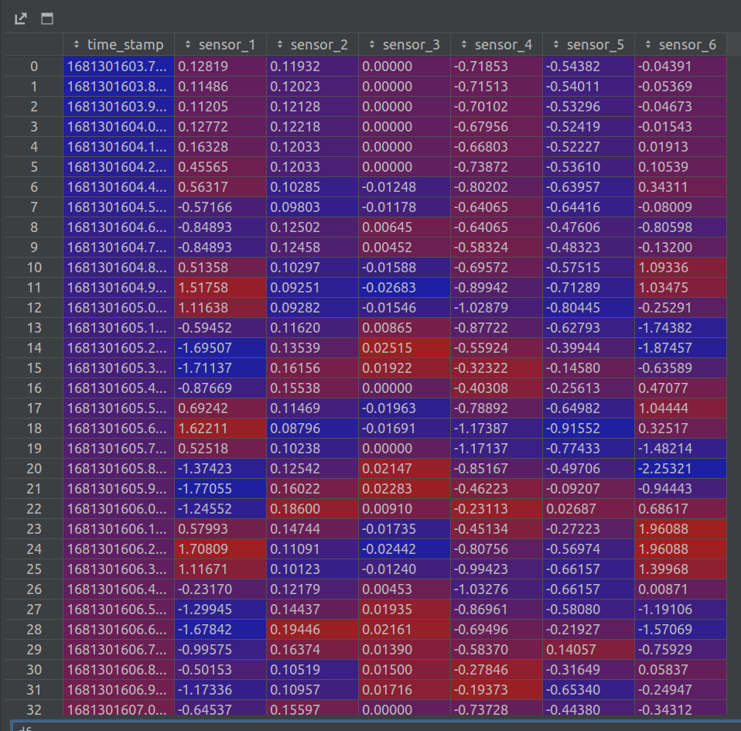

This is the initial phase, some refinements must still be done.

2023.04.13

I solved a problem regarding correct reading of measurements. Before, when my sensor reading frequency was too high, some measurements had less bytes and the next ones had more, this was solved by fixing the amount of bytes to read (to 37). This allows me to obtain the max amount of possible measurements. I started experimenting with calibration on the sensors, I realized that there is what I believe to be a small constant linear drift, more experimentation needs to be done to understand the reading on the sensor in the neutral position. I started to try to understand how to convert the sensor readings to force, the Professor recommended me to directly work with the sensor measurements instead of calculating the force. If this is to be done, I believe there must be some sort of weighting to the sensors, as I believe that there might be some that have smaller values that are more relevant to the representation of hovering that others.

2023.04.14

Today I would like to focus on the calibration problem of the sensors. I think that throughout time there is a constant drift of the measurements, so I made several experiments. I had to be careful because I was already starting to tackle several issues at the same time, so I came back to the original problematic; drift and hysteresis in the measurements. So I did the following experiments whose analysis can be found in detail in drift_analysis.ipynb Test 5.

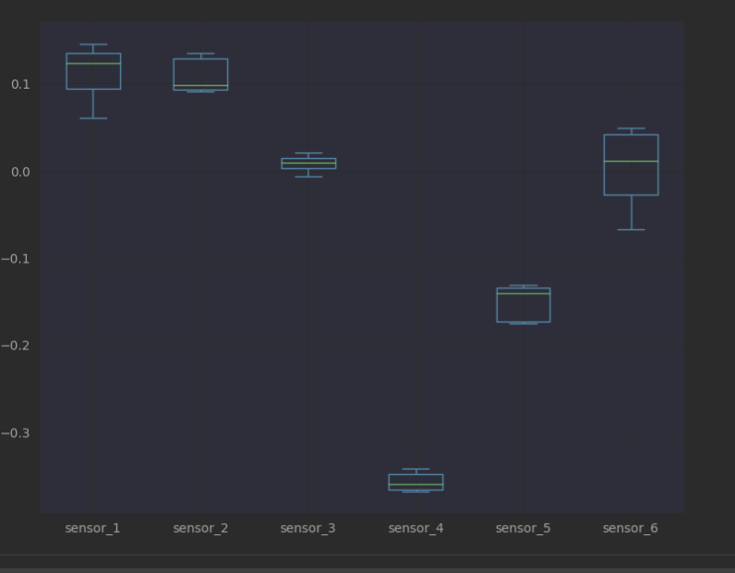

2023.04.17

I presented the results of Test 5. Then I did Test 6 in drift_analysis.ipynb which repeats the process in Test 5. This was done to see if in another day the sensor values did not change due to the DAQ. The results showed similar results to Test 5.

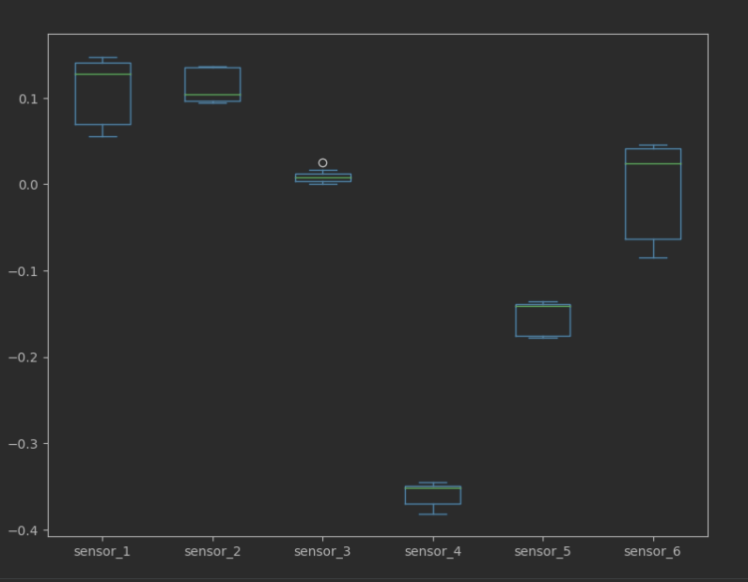

Then I did Test 7, were 27 random perturbations at different time intervals were applied. The results were similar to the two previous tests. For the time being I believe the mean values of df_dist from test_7 can be used as the sensors shift (calibration) for further experimentation. The values relate with the experiments 5 and 6.

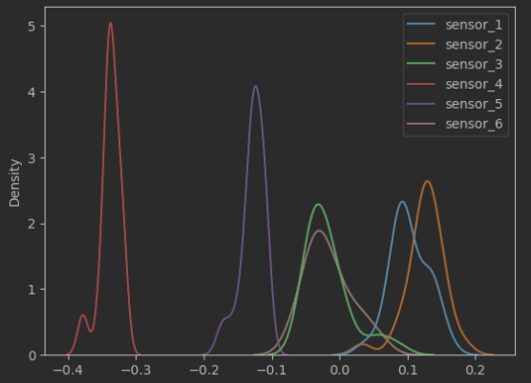

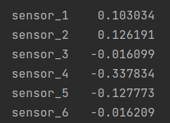

2023.04.19-23
I started to prepare the presentation “Scientific Writing: Paper Review Comments”. Made and oral explanation to Ada to better structure the “rotten Faden” of my presentation (was very helpful). Did a little bit more of research regarding good scientific writing, summarized it and applied it in the presentation. The first Draft was finished.

2023.04.24
Spent day in hospital(: Ankle stuff.

2023.04.25
Prepared Weekly presentation. Presentation was postponed for next time, as rest of the team did have the presentation on Monday (I was said it was postponed for today). Worked on NumSim homework.

2023.04.26
Starting preparing the thesis proposal. Started thinking also in possible designs of the feed forward control algorithm for the static test and its respective optimization parameters. Dr. Li showed me the new finished prototype of the Batbot, which has 2 servos on each leg compared to only the one the first version had. I asked the Professor the impact our research on hovering batbot will have in the world, as to start writing the introduction of the thesis proposal. He answered that he won’t give me the burden of that goal, that I should focus the topic of the proposal on using GA to develop controlling algorithms. I think I now understand, that what is written in the proposal should be achieved in order to graduate, that is why the selection of words is important as not to set your goal so high that if not achieved you won’t be allowed to graduate. So I started creating a draft of the thesis proposal that focuses on using GA to develop controlling algorithms on real robots, as of to skip the complications of the reality gap that most research in GA and controlling encounter.

2023.04.27-28
PhySIM HW2

2023.05.02-07
Thesis Proposal

2023.05.08
Within th thesis proposal I made an extensive literature review and had a much better understanding of future possible ideas. It help migrate the project from a vague idea to a more mature project with a clearer structure. The arguments and the motivation became clearer as well.
Here a short summary of the papers:
2023.05.02-12
Thesis Proposal

\cite{pedersen2010cma_controll_param} CMA used in robotic arm simulaiton\\

\cite{mucientes2007fuzzyga} Optimizes fuzzy controller using genetic algorithm for mobile robotics, only simulation \\
\cite{trentsiosa2022srgap}Trained robot in simulation using RL and transfered to real robot without optimization. Simple problem.\\
\cite{hansen2023cma} CMA Tutorial\\
\cite{corne2018_ea} Talks about different EA and mentiones CMA to be most widely used of ES, talks about how to choose. DEAP for python parameter choosing. Presents case studies.\\
\cite{chen2013ga_pid} simulation matlab, pid parameters using ga. Nice explanation of pid to be based on. Nice explanation of PID with GA. Proposes new algorithm. Nice straight forward explanation of PID optimization with GA. \\
\cite{wu2022daydreamer} Trains on real robot. Explains disadvantages of simulations. uses RL. trained 4 robots, one of them walking robot. This deserves a parragraph by itself. \\
\cite{zhu2020ingredients} Train real robot using RL tlaks about the challenges, focus on vision and grasping which is complex.\\
\cite{asafuddoula2011deg_realworld_problems} Real world optimization is challenging because involve large number of variables. they propose diferential evolution and test is.\\
\cite{vikhar2016ea_critic} mentions last two decades of EA development. General explanation of EA. It is applicable to various optimization problems with limited computation capability and having insufficient or imperfect information. In such situations, it provides adequately good solution. ES used in engineering. Describes many advantages. \\
\cite{back2008ea_applications} Explain 3 succsesfull applications of EA: quantum control, Optimization of Feature Detectors in Medical Images, Chemical Engineering Plant Optimization.\\
\cite{karlka2003nn_ga_robot} Train neural network using ga in simulation to obtain inverse kinematixs solution of a planar robotix manipulator.\\
\cite{narvydas2007fc_ga_mobilebot} Uses fuzzy and ga on real mobile robot, which is simple but so is ours. Good explanationo of GA. most time taken on was robot movement and fitness evluation. BUENO.\\
\cite{Sheikhan2013cma_hepatitis} CMA used for optimal controller for antiviral therapy on hepatitis B. Uses simulations.\\

\cite{Sivananaithaperumal2014} Fractional-Order Proportional, Integral and Derivative controller (FO-PID) parameters using Covariance Matrix Adaptation. Simulations. Positive results

\cite{WILLJUICEIRUTHAYARAJAN20105775} CMA for pid positive result. Simulations. Proportional-Integral-Derivative (PID). More than 90% of industrial controllers are still
implemented based around PID control algorithms, CMA algorithm outperforms all other
similar classes of learning algorithms on the benchmark multi-
modal functions. Simulation. positive results.

\cite{Yoshida2009} Nice diagram of PID. CMA better, quicker than PSO, easy to implement. used cma to optimize pid.

\cite{Guo18ants} references CMA. also uses 2 steps GA, uses real ant data as part of the score in GA, one layered NN optimized with GA. THEY ALSO USE CMA!!! and explain it. They use simulations :/ (Simulation framework: Bullet). Question, can it be applied in real world? They used a lot of parameters (Stage I 198, Stage II 608), we might need far less. Conclusion: Exiting to see they use same basic ideas(2 Stages and CMA), unfortunately they apply in simulation, but on the other hand they optimize in very high dimensions and we don’t. Might be useful for initial hyper-parameters, and as inspiration to use real bat data.

\cite{Neenu2009dc_pid} Explains traditional method of tuning PID and compares it with better performing GA optimization. Clear description of GA hyper-parameters. Mentiones traiditional PID approach Ziegler Nichols Method.

\cite{Sheroz2008fc_ga} Trains PD-FLC to controll DC motor. Explanation of PID in simulink. Explains hand tuning of PID gains. Good explanation of optimizeing FLC. The tuning of
the fuzzy logic controller can be achieved by either
adjusting the range of the universe of discourse for the
linguistic variables, adjusting the input and output
scaling gains of the controller or adjusting the number,
type and positions of the membership functions used.

\cite{Bagis2007pid_ga} used modified gentic algorihtm to find the optimal parameters of the pis controller. Uses Simulation . Comparison with normal pid. Positive results. No systematic procedure for choosing most approriate genetic operator.

\cite{Velagic2008nn_controller_mobilebot} neural network controller trained using simulation for mobile robot and backpropagation.

\cite{IRUTHAYARAJAN20099159_ea_pid} Comparison of several EA to tune PID using simulation, best are CMA and Modified particle swarm optimization

\cite{Hoe2001fc_mobile_ea} Evolutionary algorithm for fuzzy controller, uses 3 phased trainint. Simulation.

\cite{Schultz1999ga_bot_behaviour} Simulation of room with obstacles. Robot navigation using GA to train and then tested on real robot.

\cite{Silva2016ea_mobbot} Simulation of room with obstacles. Robot navigation using GA to train and then tested on real robot. 1 action is a PMV value for each combination of possible sensor info (binary off or on)

\cite{Grefenstette1994EVOLUTIONARYAI} General explanation of GA. examples of EA in robotics. Mentions neurogenetic, fuzzy controller.

\cite{Kwok1994ga_pid} found better PID gains in simulation of PUMA using ga.

\cite{Hoffmann2001genfuzzy_tut} Genetic algorithm to optimize rule base of Fuzzy and another test optimizing membership functions. Genetic fuzzy controller. Good example to learn how to apply to batbot. More of a tutorial for diffrent robots to apply genetic fuzzy.

\cite{Fan2009ga_pid} Explanation of Ziegern PID tunning and comparison to geneitc. Fuzzy mostly used for PID. Simulation, very vanilla approach.

\cite{Gundogdu2005pid_ga} Comparison of PID using genetic algorithm with Ziegler Nichols. Simulaiton

\cite{Slowik2020summary_ga_reallife} Count of papers that talk about applications in real life. Main problems, premature convergence, second trade off between exploration and exploitation. Hugh dimensionalit is a problem. EA constantly growing, always will be relevatn. (Echale un ojo mas a detalle)

\cite{Lian1999neuro_fuzzy}Tuning of a Neuro-Fuzzy
Controller by Genetic Algorithm Simulation.

2023.05.14-15

Ok, so after telling the proff,
https://simonmartin.ch/resources/stm32/dl/STM32%20Tutorial%2004%20-%20I2C%20Module%20(pca9685)%20using%20HAL%20(and%20FreeRTOS).pdf
2023.06.15

So, I know I know, long time no see.. Well, a lot of things happened. First of all I wrote and delivered my thesis proposal. It took a long time and they were very busy weeks. The professor desired to see a working experiment to show the other professors, to be honest, at first I did not understand exactly what he wanted from this presentation (apparently a very common problem with international students). So until the last day I worked on making a very basic experiment work, were the batbot moved only its legs and theta was the angular speed and the flapping amplitude. The problem that made the experiment be so basic was the fact that when all the motors (particularly the DC motor) were activated at the same time, the current needed was so high that the micro-controller and its components started to malfunction. Nevertheless the experiment was successful and for the first time we could see a batbot learning to minimize the force on the sensors. The presentation went ok, but I believed that I focused more on the general idea and they wanted to see more concrete results (which I had) it was supposed to be a 20 min presentation 20min Q&A which turned into a 1hr Q&A, the result was ok and the professor helped me a lot during the presentation. I spent the last week finishing homework, projects and exams. Now all of this is done (almost and I can fully focus on the Batbot for the rest of the time). I may have made the decision of staying until the graduation (June next year) to take advantage of the possibility of publishing many papers as well as perfecting chinese. Yesterday Dr. Li invited me to jointly publish a paper. He needs to prove that the Batbot folding wings help with the lift. So my next step is to make the Batbot fully functional and do the required experiments and measurements. This is great for me, as it perfectly fits the first part of my Thesis.

So the current state of events:
I have connected everything and labeled all the pins for easy connections. They all appear to work. As I mentioned, the only problem is how to supply current to the motors without stealing it from the STM32. From the program side we have.

uart_idleline: This is the main program, it connects the ESP8266 module and blinks a led while waiting for any command from the esp8266. If new data is received send from a client in the form of “ip-adress//$data1,data2,….,data_n! It saves each data (floats) in the vector theta (Thanks chatGPT). It uses counters to run the command for a predefined amount of time “max_time”.
So form the software part everything seems to work. The only problem is the current one.

si_si_pude: is to test the pca alone

mag_pca: is to test the pca and the magnetic encoder together
esp8266_usart: is to test the esp8266

So what is now needed is to solve only the power problem. So I have started to connect and disconnect stuff to see what works and doesn’t. The test have been preliminary and I will report more tonight when I have more worthy information.

2023.06.19

I realized that one problem that I had was the fact the the PCA stops working if one of SDA, CLK or 5V is disconnected and then reconnected. So I disconected everything and tried with new wires to find out about this problem, so then I could realize that there was a wire was loose that connected and disconnected, freezing the PCA. This was a big problem I encountered, the whole system would freeze, I hope this to be the reason and that changing the cable solves this problem. I am now testing the servo motor one by one to see how are they to be powered. Also the ranges in which the servos are activated is being tested.
2023.06.23

Ok, so after a week of finishing homeworks I am 100% back to the batbot. I will now write the most relevant findings I had and the current status.
Most important findings:
- Wires should be changed periodically, if you disconnect a wire form the PCA it freezes until restarted.
- DC must be slowly brought to the maximum desired speed. If commanded to go from 0 to desired speed it wont move.
- in mag_pca we had the first successful test of all parts form Batbot moving using this code:
int flap = 0;
int legs = 0;
int motor = 125;
int up=1;
int i = 0;
float cyc;
while (i<motor){
pca9685_pwm(&hi2c1, 0x80, 3, 0, i);
i = i+up;
HAL_Delay(5);
}
while (1)
{
angle = read_angle(); // real extreme values 6612-9702 down-up
cyc = (float)(angle-6600)/(9720-6600);
flap = 1850*(1-cyc) + 1000*cyc; // folding down-up: 1850-1000
legs = 1200*(1-cyc) + 1850*cyc; // legs down-up: 1200-1850

pca9685_pwm(&hi2c1, 0x80, 0, 0, legs);
pca9685_pwm(&hi2c1, 0x80, 1, 0, legs);
pca9685_pwm(&hi2c1, 0x80, 2, 0, flap);

- Power supply for dc motor can feed servo motors, when 3pin from dc motor is connected to PCA (shocking but true). Now we have to find a way to feed STM32, either independently or with electro magic from same supply (keeping in mind that we have had problems that components on STM32 disconnect when motor demand high current. ( I used the yellow Hobbywing as with the 50A didn’t work)

-the current range values from the servos and magnetometer can be found in the code snipped above.

Next steps:
- See if we have the correct phase of folding and unfolding with respect to flapping position.
- Dr. Li invited me to a paper with him, I have to test the advantage of the folding and unfolding of the Batbot.

2023.06.24-26

The folding and unfolding done beforehand was not the right one, as it was jus linearly deppendent on the cycle phase. The cycle (cyc) is defined as 0 when the wings are down and 1 when up. Now I developed a new function for the folding with respect to the cyc, instead of beign linear it is based on the observation of Dr Sudeep. (next Figure). As this function is not bijective (one cyc was 2 values) I had to calculate the sign of the first derivate (cyc_1-cyc_0) to see the movement is upstroke or downstroke. Then I modeled the observations on a simplified way, as a circle:
if(angle>angle_last) // downstroke
{
flap = 1425 + 850*sqrt(pow(0.5,2)-pow(cyc-0.5,2)); // folding down-up: 1850-1000
}
if(angle<angle_last) // upstroke
{
flap = 1425 - 850*sqrt(pow(0.5,2)-pow(cyc-0.5,2)); // folding down-up: 1850-1000

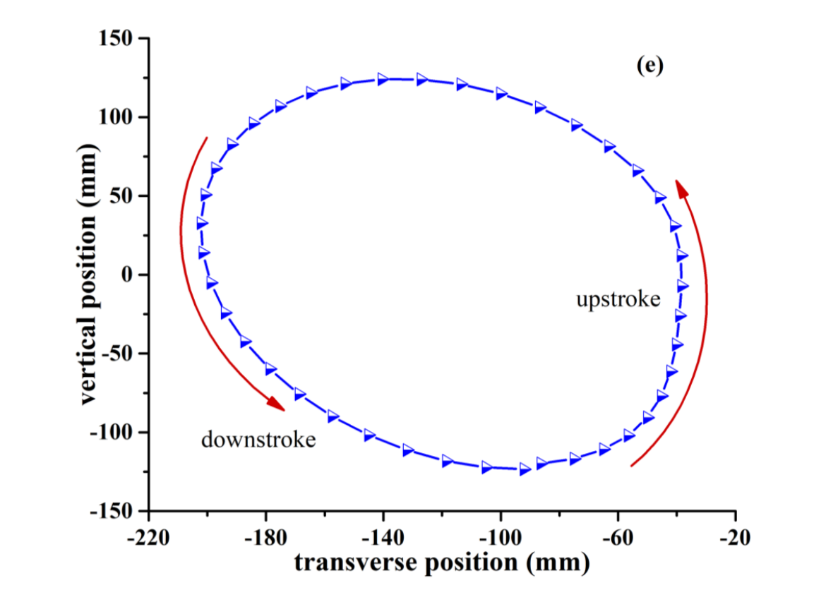
maybe in the future, if I get my hands on the real data I can exactly emulate the observations seen.

After getting the correct folding and unfloding I did 2 experiments. One with the fixed wood, and another with 5 degrees. In the fix wood I could see very good results. When comparing the lift created when folding was activated compared to only extended of folded the lift was higher and the resistance smaller in downstroke. In the 5 deg example it was not so clear.

2023.06.27

I tried to see the highest safe motor speed possible, I arrived at 250 and though to be ok. I plan to fix the angle servo moto (the one at the base of the Batbot) as I realized it moves a little bit, which can dampen the motion of the Batbot, which would influence the force measurements. Decided to ignore it for the moment.

Manually applied trust force and lift force to see reaction of forces to corroborate that my thrust and lift calculations are reasonable. Interesting to see that the values of the sensors 4,5 go very high when applying thrust force, but when comparing thrust and lift to each other it look reasonable.

2023.06.28-29

I finished the plots that Dr. Li asked me to do, I also corrected the folding algorithm, instead of following a circular path I only command the servo to fold or unfold when the cyc value has arrived to a specific value, in summary .
if( cyc>0.5) // downstroke
{
flap = 1000; // extended
}
else if(cyc<0.2)
{
flap = 1850; // folded
}

else if(angle_last<angle)
{
flap = 1850;
}
else
{
flap = 1000;
}

I used slow motion videos and different values until I found one configuration with which I was happy.

After finding the correct configurations I carried out serveral tests to make the plots that aimed to proof that folding provides more lift than extended wings the results can be found in “experiments/folding_influence/data/5deg_350motor”. For this plots, smoothing was used.

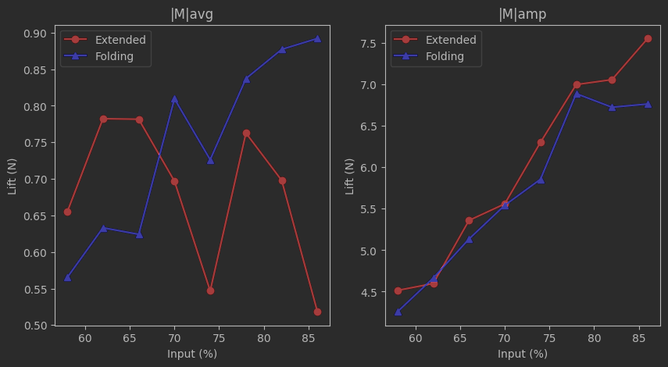

2023.07.01

The last experiments made, behavior that I don’t love. The values are recorded in very rough steps. Like this:
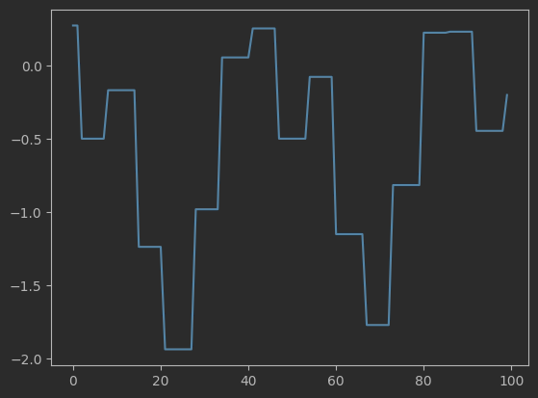

So I will try to see if using the documentation of the DAQ I can change the command I send to get more detailed data….. I tried, but had weird results, I guess it is because I limit the data to 37 byte, which used to work with the other command, instead of reopening the pandora box of serial communication I will ask Dr. Li to do measurements with his software and see if he gets better data or if it is a thing of the DAQ

2023.07.02

I managed to get the values as int, changing the serial command and the conversion of byte to int. And I still get very similar results, I will let it be for now and ask Dr. Li to show me how it looks with his software, if he gets similar stepped data I will know it is related to the DAQ and not my code nor setup.

Today I plan to do the first experiments using a GA on the Batbot with all the full capacities. I will control optimize 4 parameters. Motor power, angle of attack, leg flapping amplitude and neutral value (average value). First I will have to find out the range of values accepted per parameter (search area)

-legs: 1000-1850 (1000 was chosen as max desired angle is 45°, so until there the legs wont touch the structure, of course I could write a mapping function that maps the limits from the legs to the angle position, but for this 1st experiment I will stay with the max limit of 45° and 1850 was chosen because when testing a flapping leg motion, until 1850 there was an immediate backward response)

- motor: 150-400 (below 150, hovering is clearly not possible and higher than 400 was to fast for a simple first version test)

- angle: 1150-1450 (from 45° to 0°)

I ended up doing 4 tails for Dr. Lis robot (I found out that Dr. Li is not actually a Dr.)

2023.07.03

Today I will like to have the first test of the EA model running. A problem that came out, is that for the leg flapping, the max possible amplitude is dependent from the position of the neutral state, for this reason in this first simple test I will try having an max possible amplitude of 50% of the whole leg flapping range and the neutral value will be between the 25 and 75 percentiles.

So my new Thetas and its ranges are:
int motor = // Theta1 150-400
int attack_angle = // Theta2 1150-1450 (45°-0°)
int neutral_state = ; // Theta3 1213-1637
int amplitude = ; // Theta4 0-213

Tested different values on the Batbot… worked wonderfully.

Saved copy of uart_idleline in desktop as backup and updated the original one to the actual real test. Created a new python optimizer with the real test (batbotV1) and updated functions: command and read measurement (calibration method included).
I will start with testing the stm32 file by sending commands from a browser and then use the whole program with python. I had some doubts about the timings and workflow of the optimizer, I realized that it had all already been solved by the Anuar from the past… he is so smart.

For some reason the ESP8266 decided to not work, so I rewired it and it still didn’t work (it was a good thing either way) after conencting it with the arduino and being able to send AT commands I was also not able to get, GET request, even though It was connected and had an IP adress.. changing the pasword and reconecting everything was the solution.. no idea why… but I don’t really care.
Ended the day preparing how to save the data in files to analyze and also tested Dr. flying dinosaur and checked for lift measurements.

2023.07.04

Started testing the whole system from scratch to understand what is the problem with the ESP8266. First interesting discovery.. it works only when STM32 is restarted from the button or program reloaded, if you only connect and disconnect the program will run but for some reason new data wont be identified. Next tip, if ESp8266 not connectting restart hotspot (simply but efficient). Built everything and installed it in Batbot. Moved to experimental table.

2023.07.05

Tested flying dinosaur with Dr. Li and Yse. For some weird reason suddenly the values to run the motor go now form 500-700 (rough estimate, I will work with these but more detailed range can be found). I belive it could be due to the fact that I changed the PCA. Every component has its own perks, now I am trying to find a worklflow (connections, order of running and turning on) that works now that all components are connected.

OK primeros resultados en direccion correcta, cosas importantes a notar:
- EL PCA aveces no quiere funcionar, entonces hay que correr algo que haga que se mueva (si_si_pude) despues inmediatamente subir el programa de optimisacion.
- No puedes subir programas con el power supply prendido.
- El esp8266 aveces no conecta, si eso pasa hay que reiniciar el hotspot.
- Aveces el esp8266 conecta y esta en modo server pero el stm32 ignora la data que llega (aun y comprobando que llega). En ese caso hay que reiniciar el stm32 (supongo que algo raro pasa con la memoria cuando se prende por primera vez)
- El DAQ se vuelve un poco loco cuando hay mas cosas conectadas. Corria sin parar.

Sorry back to english…
The first test works on the first runs but then after a while goes crazy and only some motors work. The 15A converter get extremely hot (warned before by Dr. Li) Everything happends also very fast, for the test part I might add more delay to stabilize everything. When everything works properly I can start focusing on speed.
Now I will analyze the data given to see if the measuremets happened on the right moment or if we are having starting or ending measurements (which are not desired).

I took away the attack angle for the moment as for some reason the servo motor is malfunctioning (I assume It is related with the PCA, for this reason I fixed the Batbot and will continue only with the other 3 optimization parameters. If I later have time I will include the Servo but with out it it has worked wonderfully. I made a couple successful runs and edited some small things and added visualization. I will now test the result and do a mini tutorial at the same time.

Tutorial:
- Turn on hotspot and connect both stlink and usb mini(current) (might need restarting the hotspot, if wifi is connected at the same time for some reason the ESP8266 wont connect)
- Connect computer to hotspot
- Check if you can receive data form the NODEMCU to the arduino serial port, you might need to reset the stm32 to obtain the initialization.
-You can turn on the power supply but and reset the stm32 to see if the PCA is working or not (as there is an initial movement supposedly happening) most probably it wont work. So we need to send a raw movement command to the pca to wake it up.
- Turn of the power supply and upload si_si_pude, have your finger in the power supply ready because as soon as the “Shutting down… Exit “ appears in the console you will turn on the power supply, after some seconds the batbot will start flapping.
- Now turn off the power supply, upload the uart_idle line and as before as soon as it uploads turn on the power supply (OJO: the stlink and usbpower were connected the whole time). Now after the normal initialization the batbot will move.
- Change the IP address, found in the arduinos serial monitor, of the optimizer program. (you can test it with urlib_esp8226 if wanted)
- Use experiments/get_measurements.ipynb to find out if the DAQ is working and what is the port. And change the port in the optimizer
-Pray….
-Run the programm

Everything worked like a charm!!!!!
This is the way to do it. I don’t like the fact that after the test finished the servos appear to be led to weird values, might want to implement a “go to neutral” command at the end of each test. The 15A converter gets very hot, might want to check that. I also want to implement a visualization of how the score changes with each generation (some line plot with ranges)

2023.07.06

Helped Dr. Li with the paper we are writing together, made some plots and wrote a paragraph in the paper

Then I followed my Batbot tutorial and it worked perfectly, I tried changing som things to uart to see if I don’t need to do the wake up (desapendejamiento) step, did not work. Then I run some test and I start to see promising results. Here are one of the first test of 10 generations for pop 10.
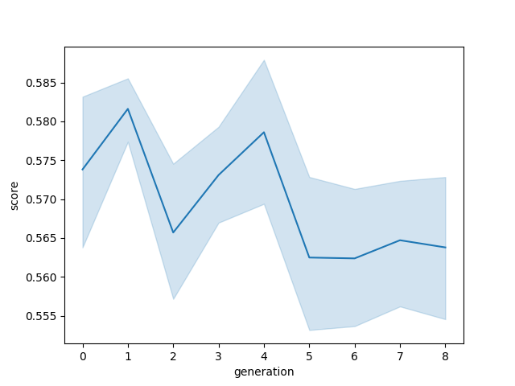
Promising (disque), I added smoothing to the reading part but have not yet tested the results (I feel bad because the experiments take long and are very noisy. One test takes around 15 seconds. In the future this number can be greatly reduced but not now. I will now also would like to check if using the whole measured data is enough or should I slice it to get whole cycles.

I made a quick analysis were I calculate the score slicing the measurement by different values and I can see a fluctuation of approx 0.025. So I believe it would be wise to only use complete periods, as the rest of an unfinished period can affect the result by 0.025 which is significant. We can see that the whole scores of the last experiment lie within a range of 0.03 (jaja) so it could almost be considered random.

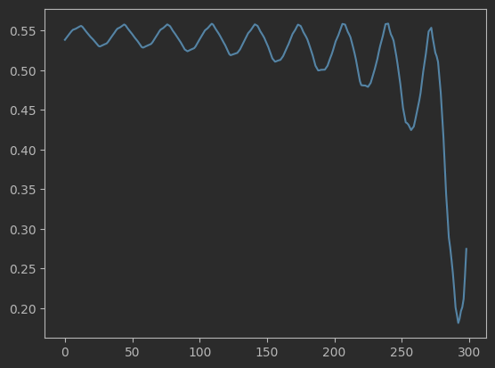

Todo:
- Implement period slicer
- Check more realistic heuristic values for theta.
- Test if smoother and neutral values make a difference.

2023.07.07

Had midnight epiphany, instead of using averages which are sensitive to tail values (values after the end of last complete period) I can approximate the average of a signal with the mean of their max and mean, this is less sensitive to tail values.

Sounded nice, but it is not very reliable, as by some measurements the max_min fitness is very close to the real value and by other it is very far.
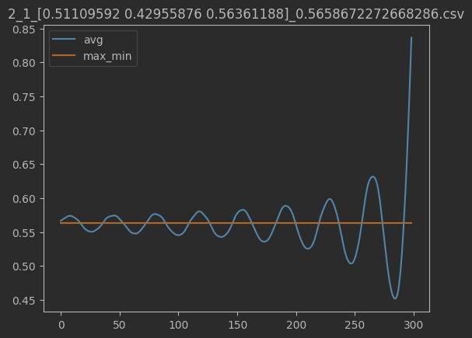
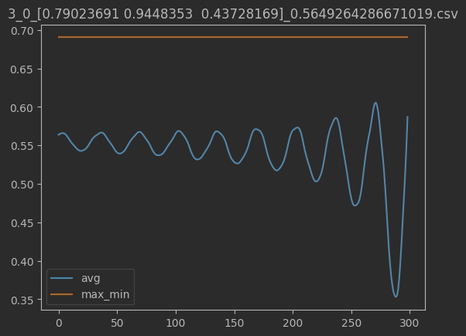
New idea, try to find out a nice way to find peak values of a signal and get the average of those to approximate the max and min value of a signal.

I found the peaks but, peak finding is a science by itself as the data can be noisy or have multiple peaks the results were unreliable. So what I did at the end to get the real result of the score without being influenced by the tail values was using a simple trick. The more data we would have gotten the less sensitive our average would be to tail values, but getting more data would mean longer experiments and when you plan on doing a lot of experiments we treasure every second, so what we can do is, from the average scores at different slicing points fit a line that projects the real average value. As seen in the next figure. We can also see the other 2 tests.

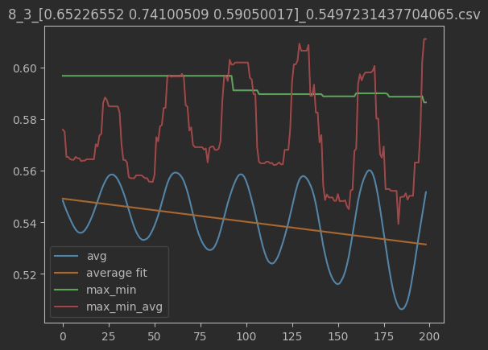

First result after applying the score projection are great.
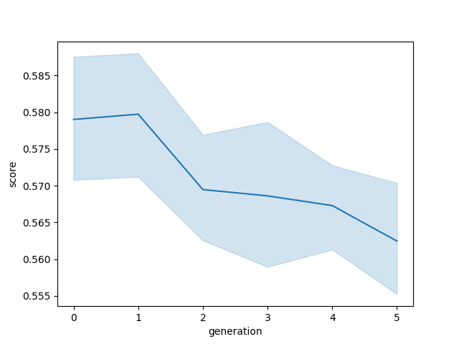
A screw from the right shoulder broke so I had to stop the experiment but that gives me the chance to test loading old optimizers.

23.07.08

Spent the day mostly on fixing how to save the data. I made it in a way so that a df that is easy to use for plotting is made and overwritten every generation, I also made it so that you can do a training in multi steps and use the information of the last test as a starting point of the next one. I made several plots to analyze the experiments done so far. This is the most relevant, which is all the experiments plotted at the same time.

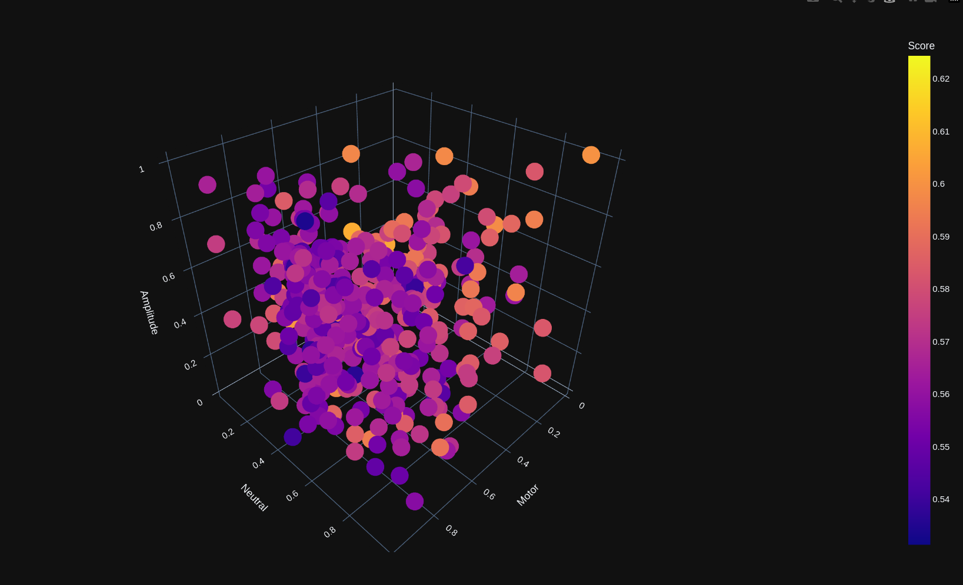

The things to take from this plot are the following. First of all, it clearly shows that it converges to the lowest score, that means that all the electronics are working correctly (yei!) Also, the Batbot learned to aim for very high motor speed, so high that it reaches the limit, so a brief experiment was made and the ranges of the motor were changed form [500-700] to [600-800] experiments with the new motorspeed are still to be done. The second important thing to note, is that the score(represented as color) is not very uniform with respect to a specific point in the 3D space. This means that maybe the same command gives different scores (an experiment could be done were 10 tests are done with the same command and the score distribution can be analyzed with the hope of having very similar results). Nevertheless, a clear tendency can be seen, an other option is to increase the population size which will make the CMA step more reliable and less sensitive to score reading error. On these first test a plateau seemed to appear at 0.54 score, but this is still very early stage to be a conclusion, we can still adapt the range, train longer, refix membrane, check calibration, etc..

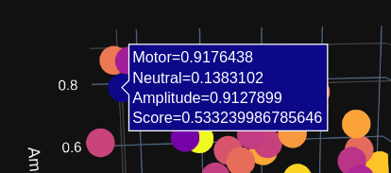
10 tests were made using the same command values:

Which were one of our best results overall, unfortunately the variance of the measured scores is to high on my perspective. Some work should be done on obtaining better quality of measurements.

23.07.09-10

There was a lot of oscillation in the system, so I took time to repair all loose screws in the test-bench. Also removed unnecessary pieces that caused oscillation like the one beneath the servo motor. We realized that the servo is not strong enough to carry the Batbot from 90° to 0°. I did an experiment with 30 generations having some loose screws and a loose leg on purpose to analyze how does the algorithm behave when achieving the optimal minima. In the next figure we can see the score in the generation.
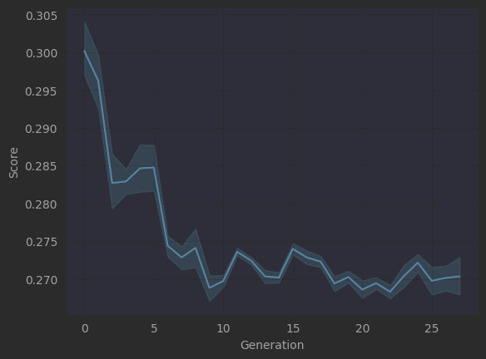
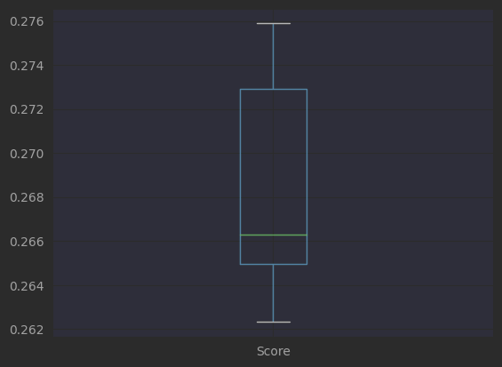
We can see that it reaches a plateau. So at the last generation I purposely only used the values of the mean of the CM of the last generation to analyze the variance the scores can have when the exact same input was given (Note: by doing this I accidentally overwrote the results.csv data). We can see the boxplot of the scores of the last generation, by using the same command value. When comparing the variance with the score values in the plateu, we can see that the algorithm is not really learning anymore as the values given are very noisy. The reduction of this noise is very important, for this, the next steps will be to identify and reduce the noise.

Curious about the variance of score within the same command I went to analyze the scores individually. To see if maybe my fitness_projection is the one adding to the error. In the next image that might seem confusion at first, we can see that the fitness_projection is working well. We can see that the score oscillation due to the tail values of each test has a mean value very different from each other. Actually, the projection (the straight lines) even compensate this a little bit by pointing to the same origin point (PAPER IDEA: Somehow, consider that the scores to be a distribution instead of discrete values and develop an evolutionary that takes this into account.”GA for non-discrete values”). This points toward the idea that the high score variance is more related to the sensor data than the calculation of the fitness function.
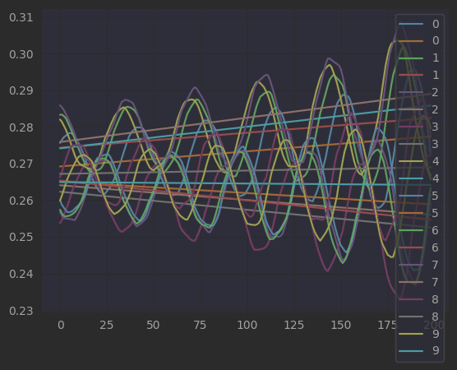

So, I tried the software of Dr. Li and the same quality of data came out. I ran the Batbot at the same command and measured both methods, here are the results.

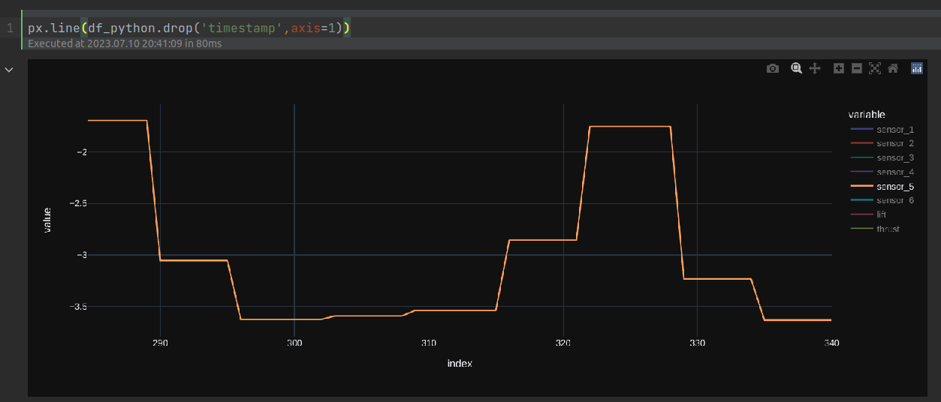

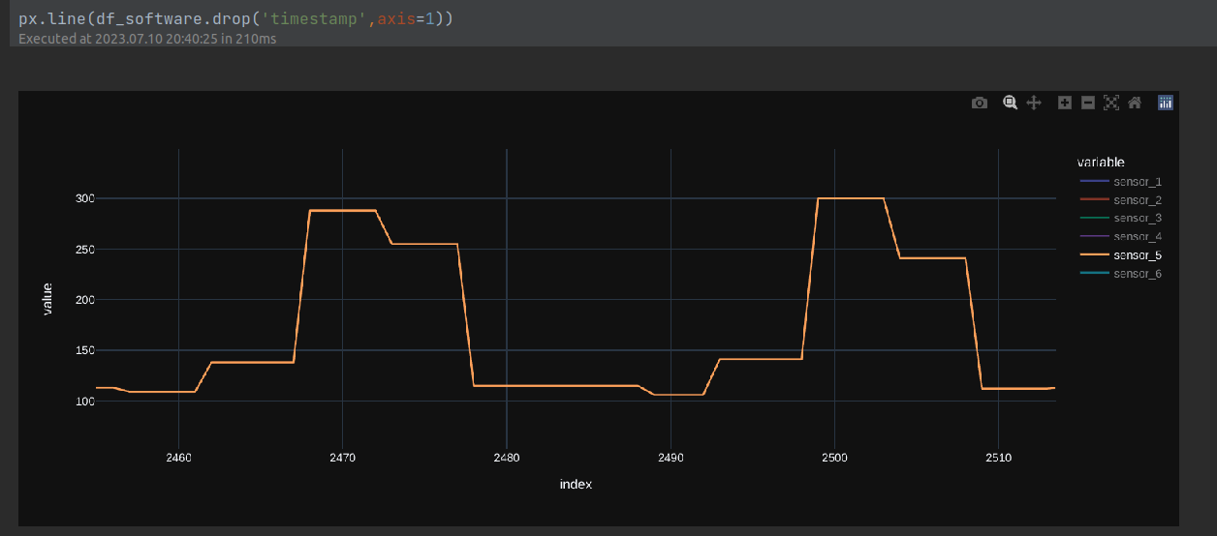
23.07.11

I tried controlling the Batbot and the servo at the same time using si_se_puede and it worked fine. I will try to work on also optimizing attack angle, because I realized that when I did a test using the servo (statically) at 0° and rope fixed at 45° we optimized for different things. By 0° it was for lower motor speed and by 45° for higher. I think this makes sense as the sensor 6 has a large amplitude because of thrust.

I half way managed to do some experiments, sometimes assisting the angle servo with my hand, and I was amazed on the results. Even by small generation I had a great improvement. This might be related to the changes I made on the structure which greatly reduced the oscillation forces, or on the fact that there are angles that are clearly better than others in a very relevant way. I was happy to see that closer to 90° and higher motor speed showed the best results at first glance, which for me corroborates logic (which is always nice). Also the scores went from 0.15 to 0.05 which is much better to the 0.5 we started with or the 0.2 at which the plateau appeared.

23.07.12

Ok, so today was my last day before my travel with Ada (noo mameeess!!). I want to do a brief summary and the next step I believe are logical in order to have an idea on with what should I start once I come back, as I am sure that when I come back after my travel I will have no idea of what is going on. So after very promising first results I plan to firstly keep finding better optimization point on the 2DOF Batbot until I cannot optimize no more and then I will change to the real Batbot. Some thing that are still possible to improve are:
- New DAQ for better data.
- Replace membrane that is already broken
- Get angle servo to work properly
- Longer training sessions were a better optimal are found. (including new ranges of possible solutions)
- Rethink leg algorithm using heuristics for a better search area. (idea of smart mapping to avoid isotrop corners)

Brother…. Enjoy your trip!(:

23.08.10
I am back from my trip (amazing!) I feel charged and ready to keep on the research (:.
I briefly reread my notes of the last weeks before my departure I had some thoughts. This might not be the labs favorite idea but I think a good multi-axial sensor might be a good idea as it would make us forget the forces that are measured by the torque generated by the distances between the Batbot and the sensors. Today I will try to get everything back to work and then will focus on making the angle servo work properly.

23.08.09-23.08.29

Bat wing leg ratio:
22.5/6 = 3.75
34.5/8.5 = 4

Our bat has wingspan of 68*2 = 136

Ranges of magnetic sensor at speeds from 260 to 270 in steps of 1, using angle 120:
[(190.674, 230.414), (191.136, 230.48), (191.268, 230.59), (190.916, 230.502), (190.212, 230.59), (190.498, 230.678), (190.652, 230.678), (190.784, 230.7), (189.86, 230.524), (190.278, 230.502)]

Ranges of magnetic sensor at speeds from 260 to 270 in steps of 1, using angle 90:
[(189.486, 230.502), (189.486, 229.556), (190.278, 229.622), (190.08, 229.842), (189.772, 229.776), (188.936, 229.336), (189.288, 229.314), (190.212, 229.028), (190.014, 228.918), (189.97, 229.402)]
decision: use ranges from 189-231 (revoked)

Lot of time spent calibrating the magnetic sensor.

23.08.30
Ok, so a lot has happened, but as at the beginning it was mostly updating the system I did not write so much, but I have arrived to a point were a log is once again necessary. This is a quick summary of the last 3 weeks. When I arrived there was this guy called Richard that wants to apply for his Phd with us in the Lab. He studied measurement and controlling, we introduced me to the PyBoard and I was fascinated. So at the beginning I was focused on migration the whole program to PyBoard. With the PyBoard I don’t use the wifi module any more, instead I use a wireless uart. He also helped me realize of some wiring errors that I had using the PCA. Once the PyBoard was setup and I knew how to use it, I could finally control everything from the computer without a problem, it is much more straight forward and it will make my live easier when programming feedback controllers. Then I helped Dr. Li with some experiments with the Batbot V1 (with only once servo per leg) and then because of this I had to start using the Batbot V2. I spent a while programming the movement of the legs and also manged to define the parameters that will control the elliptical movement of the legs. There was some time spent in general mechanical stuff of the Batbot (building wings, putting membranes, installing magnetic sensors, wire management). Richard also tried to create a DAQ that would give us better data, at the end it gave more samples but at lower accuracy, so yesterday I changed back to our old DAQ, that only gives 10 uniques values per second, which are very accurate. The sensor plots it gives are remarkably periodical which for the moment is better than the noisy data the other one gave. There was also a lot of work done on project organization in general. So after all of this I was finally able to get back to doing experiments. Here are the first results and current status:

Using the old data we can see that the scores (color) are very noisy:
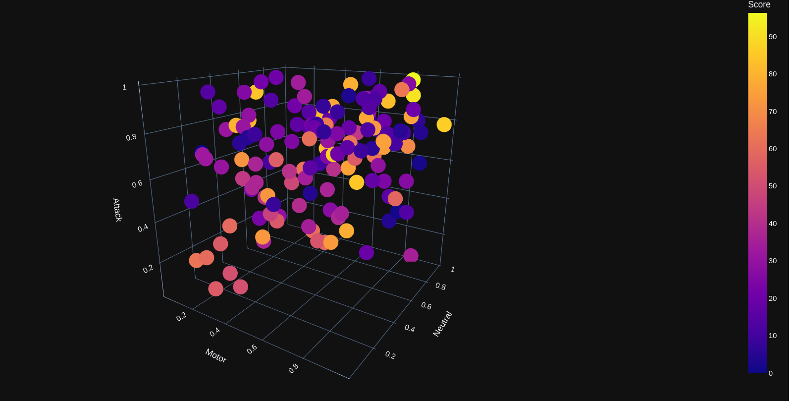

Here, were we only optimize motor and attack angle we can see the same:
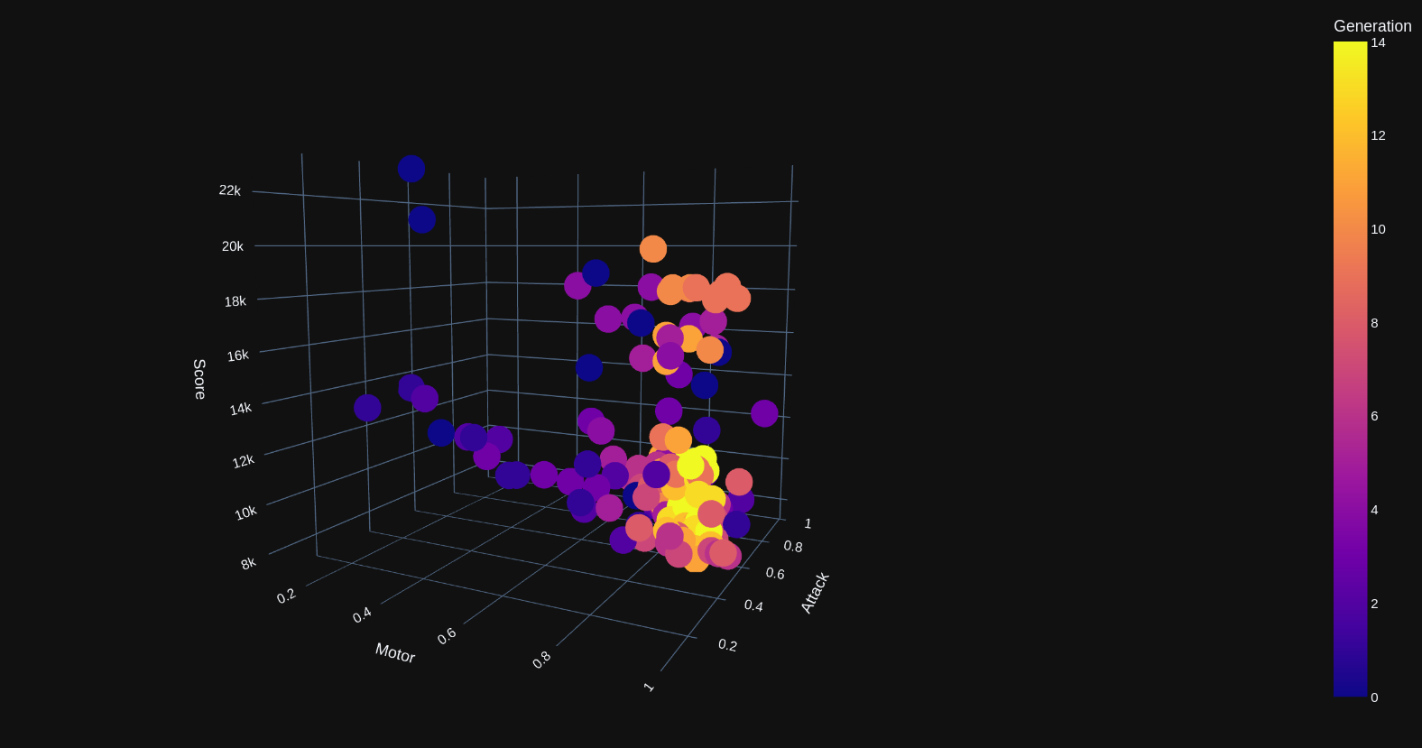

So I that is when I changed the DAQ and had the idea of making a grid test. If I am in only 2D I can to 100 point to cover the grid. The plan is to do 10 test per grid point and analyze the variance of the score at each point. Here is the result of only one iteration (because I had to leave early yesterday), but the results look very promising:

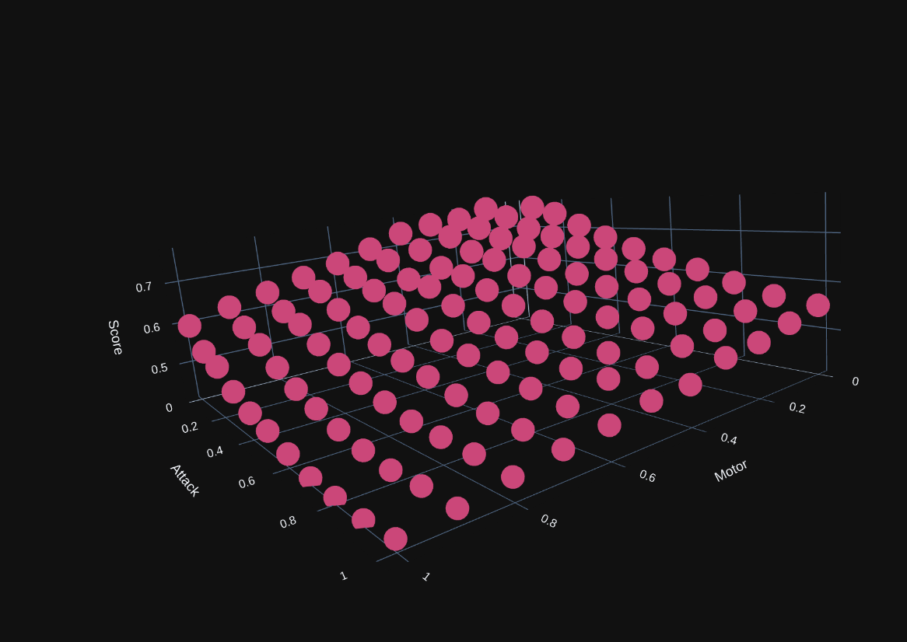
We can clearly see that a much clearer score function is to be seen. It looked so good that I had to check in detail to find small variances in the data because it almost looked like an analytical function. Luckily small error that proved that the data is real were there.

Note: more detailed explanations of each experiement are found in the log.txt, here I will start to only write ideas and conclusions.

So that is the current status. Here is what I plan to do next:

- I want to calibrate the sensors again.

- do the 10 iteration grid test to analyze variance and also compare it to the one done yesterday to test repeatability.

- Then I want to optimize first only motor and attack with extended wings, then with folding and unfolding then using the leg motions (7D). The idea is to see a progressive improvement that stagnates and only keeps improving after the next test.

- For now, the square of the mean of each sensor is used as score and also using the project strategy to overcome the change on scores do to the tail data of a period. But I have started thinking on using the squared value of the measurements, because this way we also punish high amplitudes.

I did 3 generations of grid test and also added in results_combined.html the results of 230829. So in total we had 4
grid search generations. The scores showed to be stable, as all the scores for a solutions had a small variance, the
score function was clearly and smoothly seen in each generation.

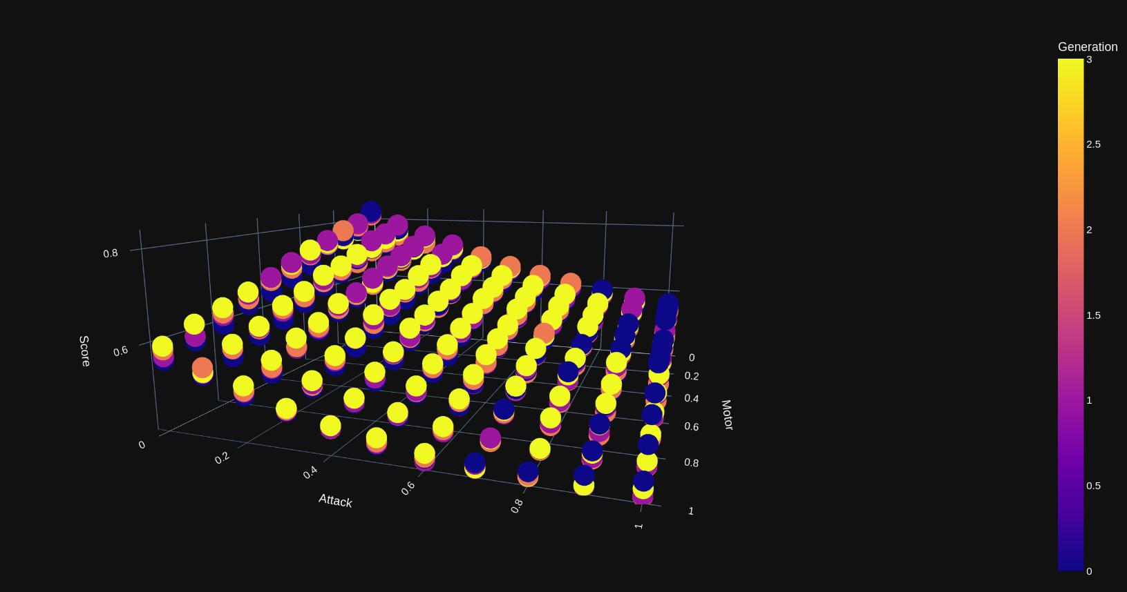
Because of the acoustic noise generated, I decided to stop at only one generation. The results were so smooth and from
the experience of the last results I can confidently use this results for analysis without the need of repeating the
experiment several times (at least for now).
In experiments/optimizer_batbotV2_2D/data/230830/grid_test2/results_compared.html we can see the score comparison of one
experiment using folding and other extending, it can be seen that when using folding in almost each grid point the score
is clearly smaller.

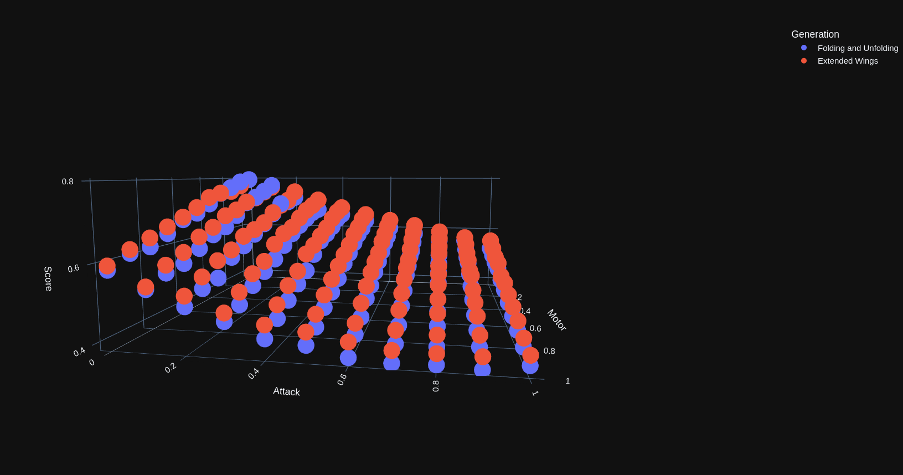
Then I started to optimize the Batbot using the CMA and folding and unfolding to find the best value but at the 6th iteration the shoulder broke.

2023.08.31

Spent the whole day repairing the pinche Batbot. Then took advantage that the Batbot was unmounted to calibrate the sensor, results were saved in analysis/sensor_calibration_oldDAQ.csv.

2023.09.01

I was unsure of how correct was the calibration and if wether it had a high variance form measurement to measurement, so I made an experiment were I would measure on the unmounted test bench 20 times the “calibration” values with perturbations of the test-bench between each test. I repeated it twice and got similar results. Here is the boxplot of one of them.

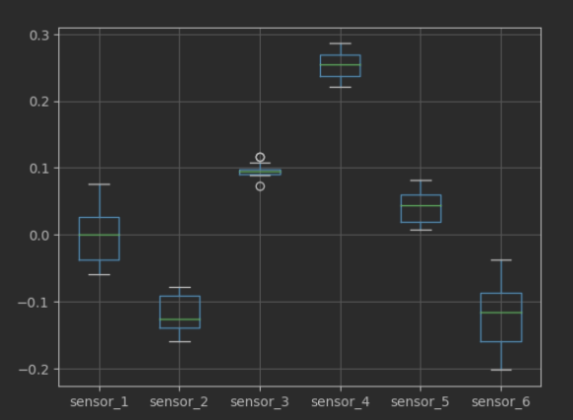

We can see that the largest variance is of around 1.6 (sensor 6). To see how relevant this is I mounted the Batbot at 120° and 80°. Here are the results. (upper tilted, lower horizontal)

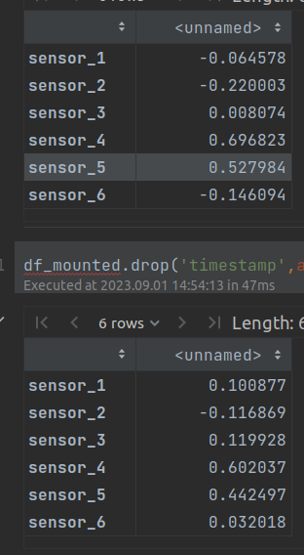

We can see that some sensors don’t have a big difference (sensor 1,2,3) never the less 4 and 5 have a large difference, which means that I can use the median of this calibrations at least at the beginning, I can later see if I can assign weights to the sensors when calculating the score. Also, the difference of 4 and 5 is so large that the small difference of the other can be neglected in the calculation. So I decided to use the median value of the 20 test as calibration.

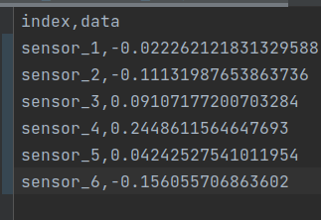

Note: With this calibration the static score horizontal is 0.27836001317748427 (even thoug 2 seconds ago was 0.4791767226154238) and the vertical is 0.44779044654606975. Thes best obtainable score is 0.005945446602190579.

2023.10.26

Ok…. So …. uy…. Long time no see… hehe. For real now.

A lot has happened. I will try to summarize the advancements, I return now to the daily journals as I intend to restart the experiments from 0, so I believe this is a good moment to start documenting the progress.

I made a series of successful experiments.
Between 2023.06.25-2023.09.22 (there are logs in the experiment) I did several tests optimizing flapping frequency and attack angle. Working on the structure and implementing the score analysis of only periods (instead of the whole experiment data) showed a very nice continuous curve (right) compared to the first experiments made (left), were the score variability for the same experiment was too high.
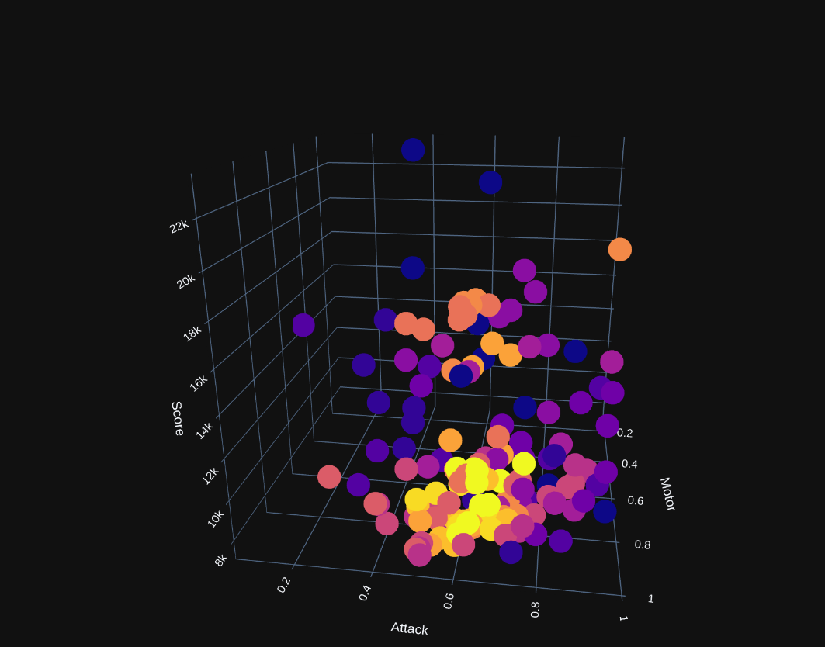
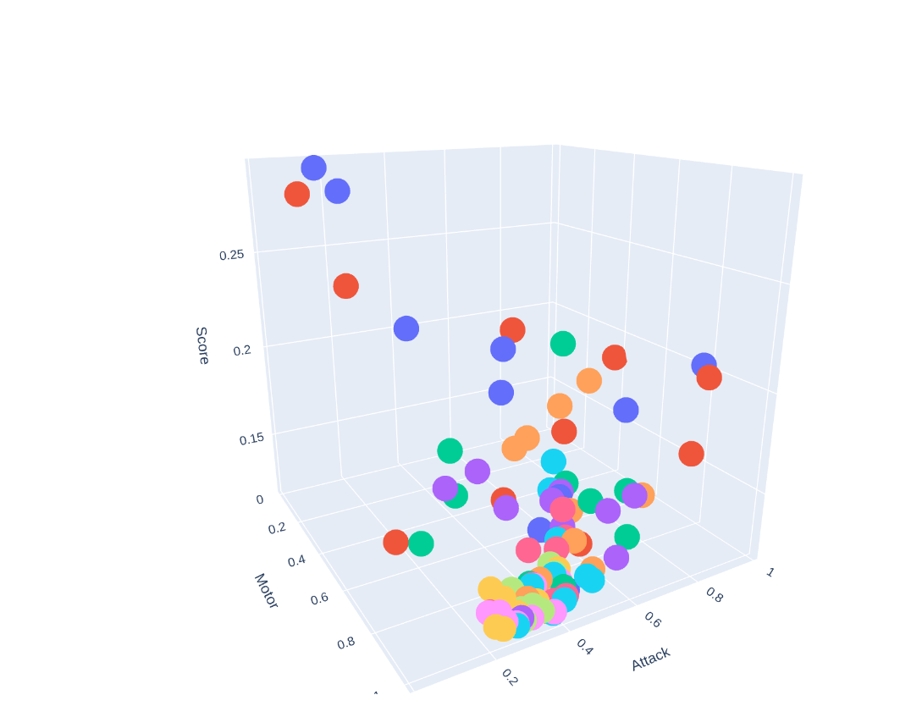

From the last experiment we can see that the results converge to one point, which is feasible as it tends to the highest possible flapping frequency and a reasonable angle. The important thing to notice is the smoothness of the curve. This experiments were done fixing the legs in one position. Once the optimal angle and flapping frequency were found the legs were optimized in a set of experiments (5D) carried on 2023.09.19-20. Were once again we were able to converge to a value.

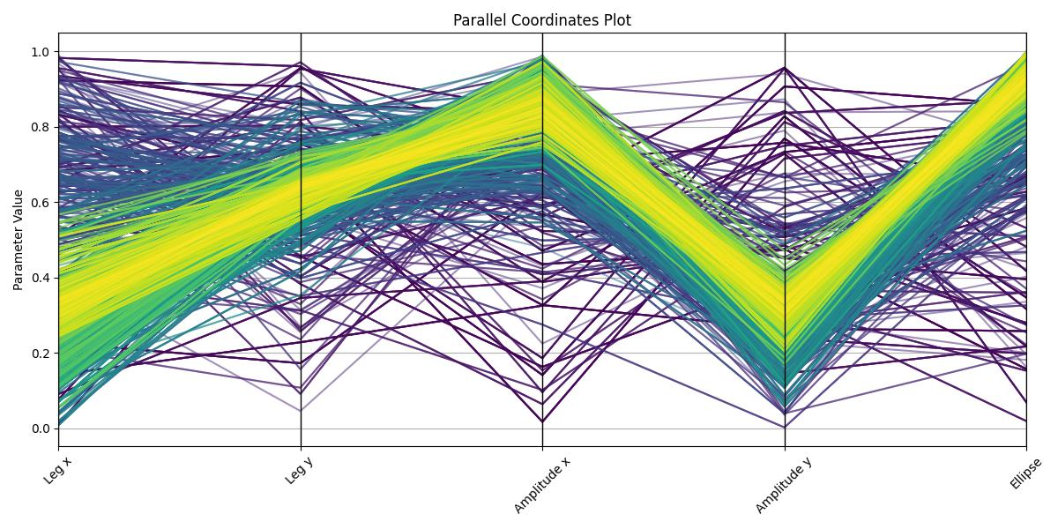

Additionally, rewiring and restructuring was done to do experiments outside. Experiments showed that the Batbot is very stable while flying, which should do the controlling much easier. I also was able to halfway control the Batbot using an Xbox controller.

The big issue with this last experiments, was that the data is not so good and the testbench does not give force data, for this reason we bough a 6 axis sensor. With this new sensor much better analysis can be mead and I can trust more the data I get. For this reason, I will start from the “beginning” using the new sensor. Which is why I decided to return to this journal.

My plans are the following:

- Find the angle in which the Batbot makes the largest lift using the 6 axis sensor and reposition.
- Redo 5D optimization
- Optimize to find the movements needed to create largest torque in 3 axis needed (used for future feedback controller)
- Research on feedback controller and ideas
- Use hanging test-bench

2023.10.26-2023.11.16

As most of the experiments now are mostly based on experiments and data collection, you can find a detail explanation of the steps taken this last weeks on the python file analysis/forces/231115/batbot_dynamic.ipynb, as well as in the logs found on each experiment carried between this dates. In summary, I have updated the system for the new sensor. Here is an example of the visualization of a test:
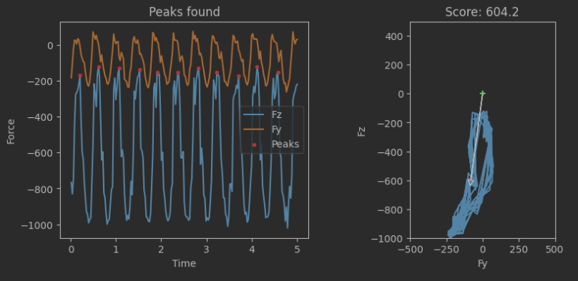

We identify peaks and only consider complete cycles in our analysis, we use Fz and Fy and calculated the average force and try to reduce it. I found some preliminary results that let me do the first flying hanging on the elastic, when I tried to increase the flapping frequency the gear broke. So I updated one of the Batbots that achieved normal flying to have the 2D legs. I showed my results to the Professor and he was happy. Now I have to present my results to a group of other people. For this reason I will start from 0 again all the data analysis and experiments using the new Robot and get the final data and plots needed. I will do that in the file analysis/forces/231116/batbot_dynamic.ipynb. Also, rewiring was done and debugging of the wireless communication. Now one power source is enough to run the whole thing, compared to before that the usb must have also been connected.

2024.04.05

Ok ok ok, sooooo 2 weeks before deadline, here is the last entry I guess, thank you for everything!
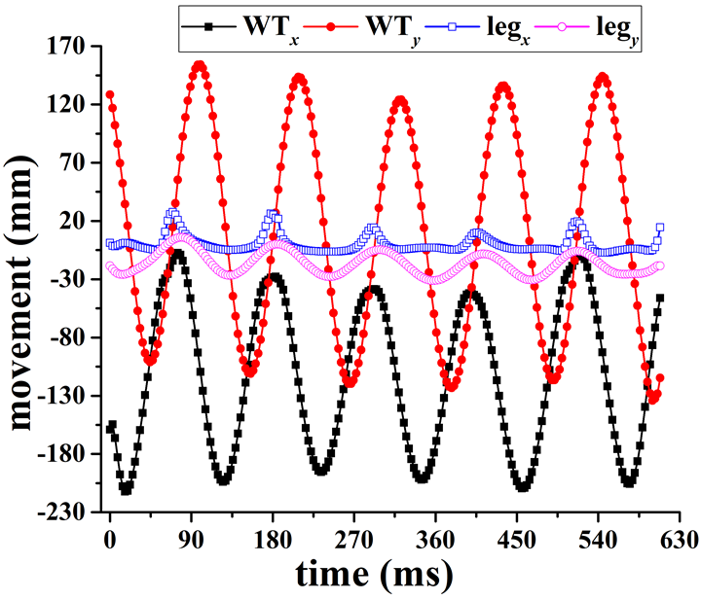

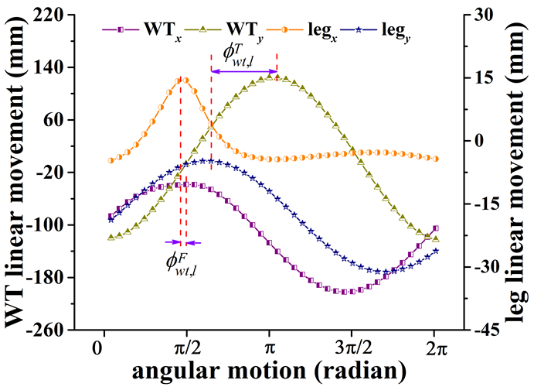

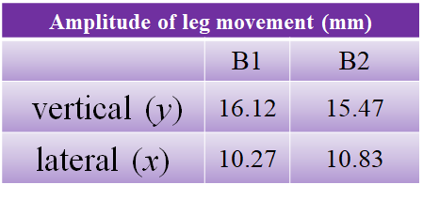

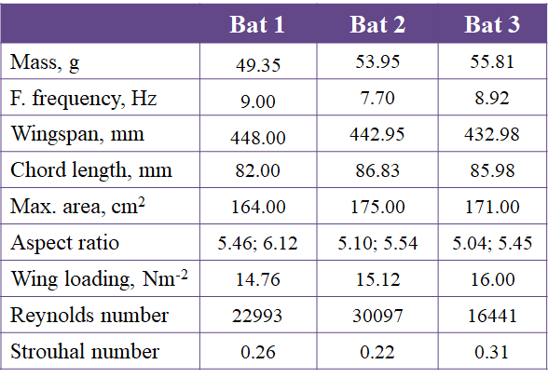

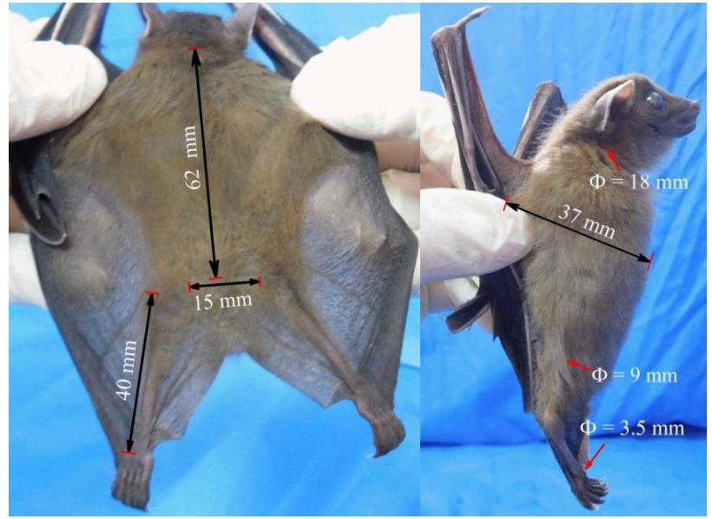

Measurements, Batbot, Bat, ratio
wingspan, 1446mm, 445mm, 3.19
body, 277mm, 62mm, 4.47
leg, 130mm, 40mm, 3.25 (I respected the wingspan radio and cutt the legs)

Escribo estas ultimas palabras mientras mi robot aprende a volar como un murcielago real, cada plot que sale es mejor que el otro, estoy realemnte feliz… osn las 3 de la manana y estoy a 10 dias de la entrega y aun no he empezado a escribir, pero finalmente puedo dar por concluido con este proyecto. Ha sido una aventura increible, he crecido muchisimo aprendido muchisimo, ese anuar chiquito que aun vive en mi no puede ser mas feliz de todo lo que han llegado a ver sus ojos. Estoy muy orgulloso de el y de mi. Que se venga la siguiente aventura, como dirian los Jorges, este fue otro fin de semana exitoso(: Que se agarre el siguiente.

